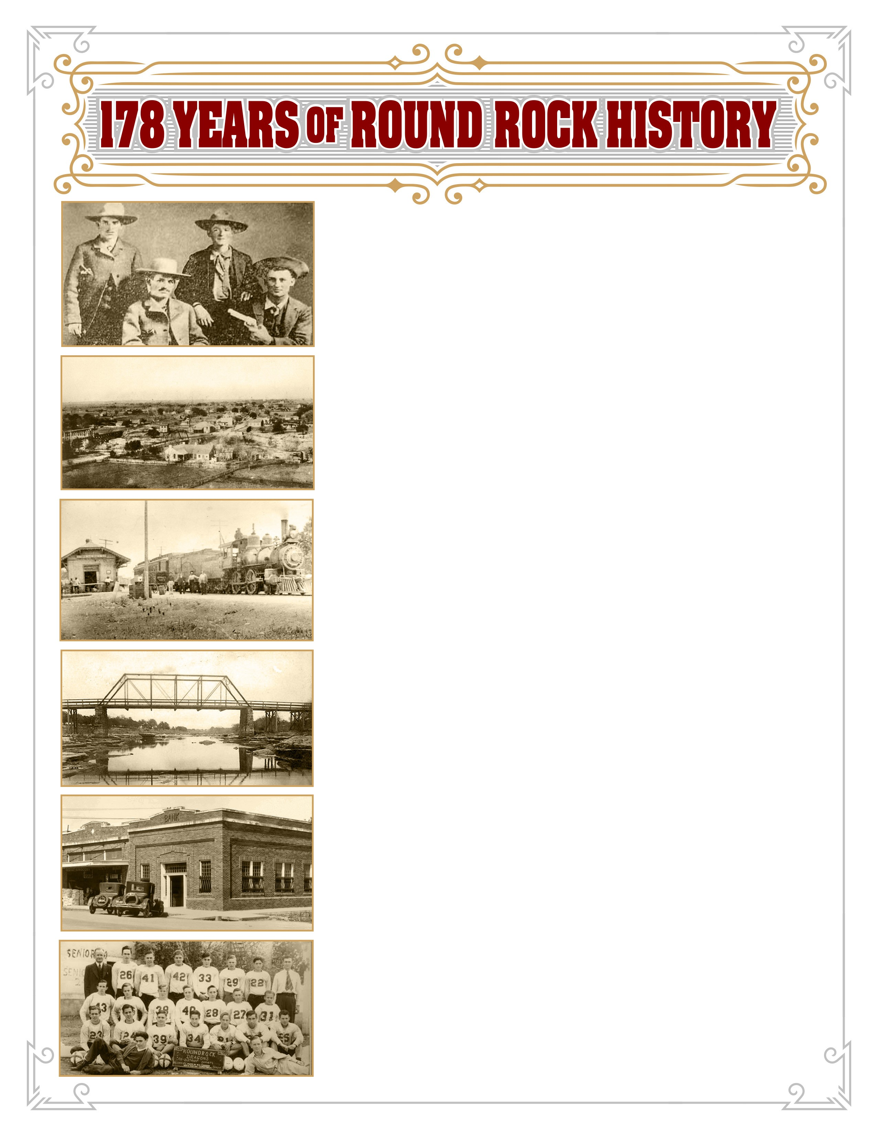

*Presented by*

**Karen R. Thompson**

Author of numerous Round Rock history books

**Date:**

Saturday, May 13, 2017

**Time:**

Program 7-8 pm

Doors & information tables open at 6:30 pm

**Place:**

Round Rock Library, 216 East Main Street

*The library will be closed;*

*please use the Liberty Ave. (north) doors.*

**Sponsors:**

City of Round Rock Historic Preservation Commission

and Planning & Development Services Dept.

www.roundrocktexas.gov/historicpreservation

Round Rock Preservation

(512) 373-3819

*(501c3 Public Charity # 81-2339800)*

**Admission: FREE**

**Round Rock Preservation welcomes**

**donations for the Stagecoach Inn**

**relocation & restoration project.**

***www.rrpreservation.org***