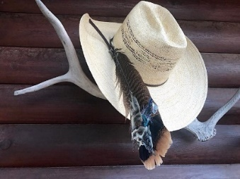
PRESIDENT’S CORNER. Everyone has earned a feather in their hat. The best news of 2021 is the City of Round Rock approved in the FY 2022 City Budget to annually fund historic preservation at a rate of 3% of Hotel Occupancy (HOT) Funds for Historic Preservation Projects and another one-time allocation of $300,000 for the same purpose. That would not have been possible without the help of supporters like yourself. Thank you!!!

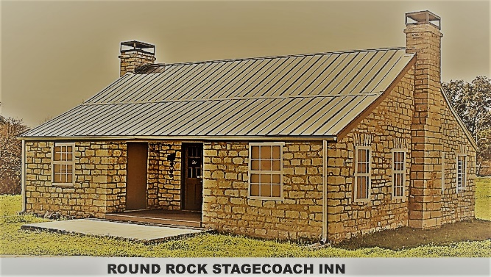

The next issue is, will the city designate 100% of these funds to restore the Round Rock Stagecoach Inn? RR Preservation couldn’t schedule a meeting with the City until November 2021 to discuss this issue. As of last week, the City had no plans for the use of these funds. Everyone can help by going on-line or talking directly to the Mayor, City Manager, and City Council to ask that 100% of these funds be dedicated for the restoration of the Inn until that project is completed. Every call or contact will help.
In this victory, there are no guarantees and know that the voice of the public does count. Help RRP secure the victory of the Historic Preservation Funds being used for the RR Stagecoach Inn Restoration Project.
Shirley Marquardt
President, Round Rock Preservation (RRP)

STATUES FOR
HERITAGE TRAIL WEST

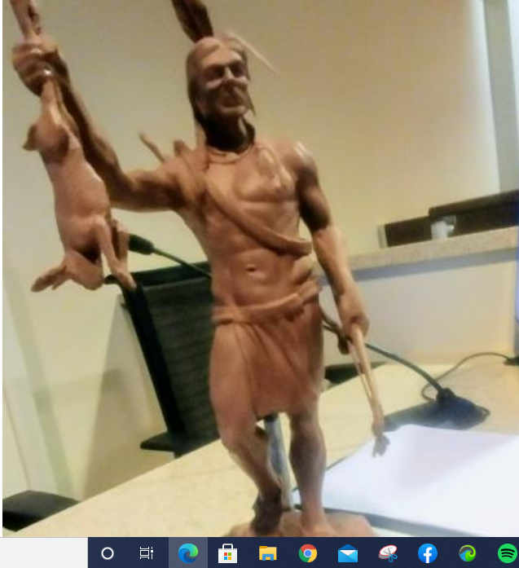
Tonkawa Indian

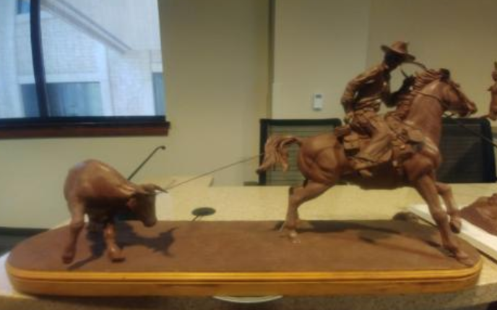
Cowboy Roping Steer

At the last City Council meeting, the City of Round Rock approved the creation of up to 10 statues for placement by the Heritage Trail West Project (on the banks of Brushy Creek within and near the Chisholm Trail Park/Bathing Beach Park area). The above photos are clay models of the first two statutes. The 10 statutes will help depict the early period before and after the pioneers came to the Round Rock area. The statues will be developed over a 60-month period. The artist is Antonio Munoz from Round Rock. His studio will be open occasionally for citizens to observe the work in progress. This artwork means more visibility for Old Town Round Rock and helps highlight our rich past.

WELCOME A NEW BOARD MEMBER. Sylvia Forbes was appointed to fill one vacant RRP Board of Directors position on September 14, 2021.

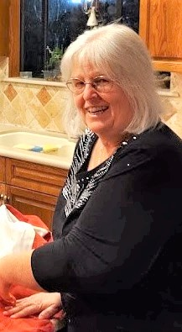

Sylvia is highly qualified to serve on the board and lives in Round Rock. Sylvia comes to RRP with a vast amount of historic preservation experience that she gained while living in Missouri. Sylvia briefed the City Council on September 9 speaking on a need in Round Rock for a way to preserve Round Rock’s historic artifacts and history, since some of these capabilities were lost to our city with the closure of the Palm House Museum and the closure of the Williamson Museum on the Chisholm Trail. Sylvia will be a great asset to our organization. Sylvia envisions the need for a Multi-Cultural Heritage Center within the City of Round Rock. Welcome aboard Sylvia.

CURRENT BOARD OF DIRECTORS

SHIRLEY MARQUARDT, PRESIDENT
FRANK DARR, VICE-PRESIDENT
JUDY ANDERSON, SECRETARY
KERSTIN HARDING, TREASURER
SYLVIA FORES, DIRECTOR
PHEBE DAVOL, DIRECTOR
RICHARD PARSON, DIRECTOR
BLYTHE PLUNKETT, DIRECTOR
TINA STEINER, DIRECTOR

The RRP Board of Directors meets once a month by Zoom on the second Tuesday of each month at 7 p.m. If you want to watch the board meetings, send us an e-mail and we will add you to the meeting invite list.

Shirley and David Tynan, former directors on our board, moved to Colorado in early August 2021, so we are seeking candidates to fill both their positions. These two vacancies on the RRP Board of Directors need to be filled. Send us an e-mail (roundrockpreservation50@yahoo.com) if you are interested in serving on our board of directors.

ROUND ROCK PRESERVATION THROW
RRP has a “RR Preservation Throw” under design. When the design is completed by the contractor, we will offer the throws as a fundraiser with delivery arriving just in time for the holidays. The size of the throw will be 68” x 48” and will be available in cranberry red with a white background. The images on the throw will include Round Rock’s historic sites/structures.

ENGRAVED BRICK PROJECT

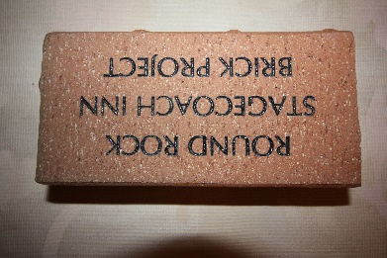

The Bathing Beach Park Project is a part of the Heritage Trail West Project. The Bathing Beach Project will be completed as the last task in the project (along with the installation of the RRP Engraved Bricks that individuals and businesses ordered). We estimate that project will be completed by March 31, 2022. We will have a dedication ceremony at the brick display once the park is completed. The Bathing Beach Park project will also include landscaping around the RR Stagecoach Inn.

