PRESIDENT’S CORNER.
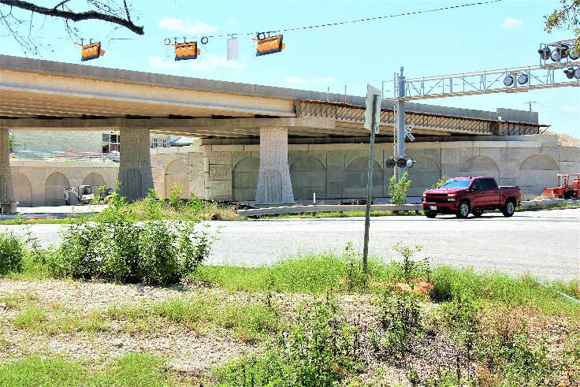
On top of the new RM 620 overpass bridge is the original location of the RR Stagecoach Inn prior to its relocation in 2018 out of the Commons Business Complex.
Last year, the Round Rock (RR) City Council approved $300,000 to fund the interior restoration of the Stagecoach Inn using funds from Hotel Occupancy Taxes (HOT). In addition, annually 3% of HOT funds will be dedicated to fund other historic preservation projects. HOT funds are generated from taxes collected from individuals staying in RR hotels and do not burden taxpayers with these expenses.
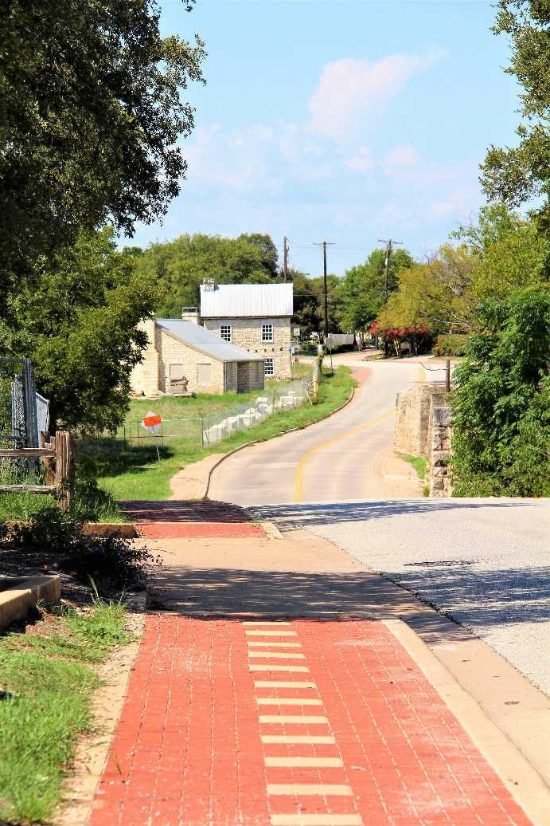
The Round Rock Stagecoach Inn traveled down this road to its new home (750 Chisholm Trail Road).
The FY 2023 City of Round Rock “Proposed Budget Highlights” Brochure states the proposed FY 2023 budget includes additional funds for the restoration of Round Rock’s historic Stagecoach Inn. In searching the city’s website, the draft budget lists $386,000 for the restoration of the Inn from Hotel Occupancy Taxes, which is an increase of $86,000 over last year’s budget estimate.
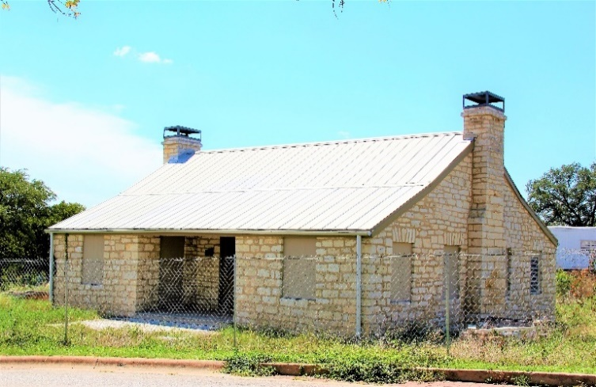
Behind a fence, the Inn awaits the start of the final phase of the RR Stagecoach Inn Restoration Project.
After four years, the restoration of the Stagecoach Inn Project is once again underway. The project will include a new wood roof, new ceiling, new wood floors, new wood doors, new wood windows, repointing of the interior if needed, electricity, AC, and ADA compliance, etc. to make the facility accessible to the public.
About a week ago, the City Parks Department informed me the consultant (Architexas) has completed 50% construction drawings for the Stagecoach Inn Project. The consultant is highly regarded in the Texas historic preservation field and will keep construction designs in line with original historic aspects of the Inn,
The 50% drawings are being reviewed by the City Parks and Recreation Department and the City Historic Preservation Office. The Stagecoach Inn Restoration Project is expected to be completed in late 2023.
Shirley Marquardt (President, RRP)

www.rrpreservation.org
HERITAGE TRAIL WEST PROJECT.
The Heritage Trail West Project (Walk & Bike Trail), which stopped last summer due to the bankruptcy of the contractor, is also on the move again. This project includes the installation of the “Round Rock Preservation Engraved Brick Display” (which will be located near the Old Round Rock Stagecoach Inn in its new location).
The City has worked out a settlement with the insurance company and has hired a new consultant to identify what needs to be completed on the first contract. Last week, Katie Baker (City Parks Manager) informed me the City Parks Department expects the project to be underway around November 2022 and completed in late 2023.

PALM HOUSE MUSEUM.
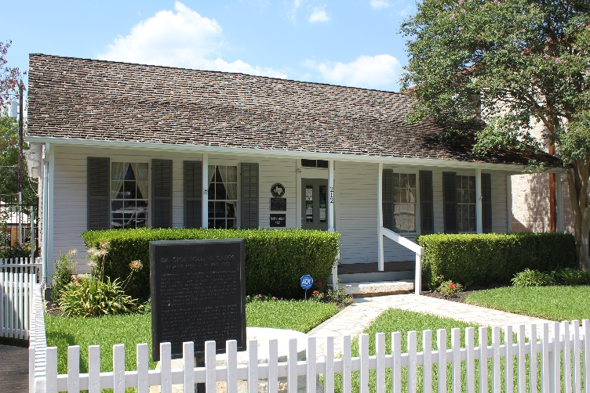
Palm House Museum
Last month, Brad Wiseman (Director of Planning & Services Dept) informed me, the City of Round Rock has plans to upgrade the old library once the move to the new library takes place around January 2023. Once the upgrade is completed in about a year, the RR Chamber of Commerce, the RR Visitors Bureau and part of the Arts and Culture Department will move into the old library. At that time the city wants to relocate the Palm House Museum and create a special breezeway between the old library and the new library.
Wiseman told me he believes the City of Round Rock is on board to relocate the Palm House back to the Old Settlers Association grounds (near its original location). However, since the Palm House has a state historic designation, the State Historic Preservation Office must also be on board with the proposed relocation. A state representative has already visited Round Rock to look at the proposed new site for the Palm House; however, no decision by the State has been made.
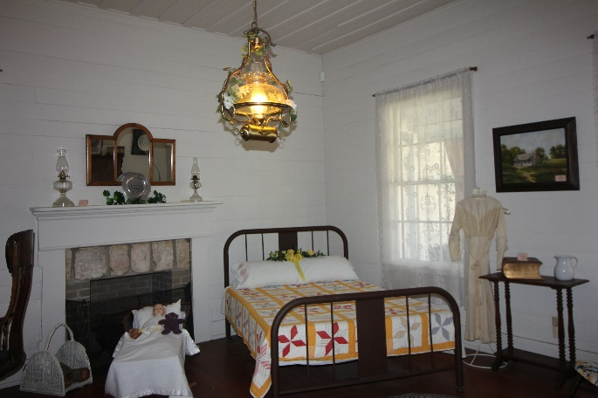
Bedroom at Palm House Museum
The Old Settlers Association appears to be on board with the proposed relocation of the Palm House. Old Settlers Association expects to meet with representatives of the Palm House Museum Association to discuss possible relocation the Palm House historic artifacts so the artifacts can be housed inside the home. Protection and security of the artifacts will be an important issue in any proposed agreement. It is the hope of everyone involved to have the Palm House once again be reinstated as a museum with regular events taking place at the new site.
RR HISTORY THROWS.
The 2022 holidays are just around the corner and everyone will be looking for the perfect gift(s) to present to their loved ones or friends. RRP has the perfect gift.
The unique RR History Throw is a perfect way to warm your guests, who stay in your guest bedrooms, or warm their hearts when they see Round Rock’s significant historic structures displayed on the throw.
RRP only has a limited number of RR History Throws available. Each throw is made in the USA and is made using red and white woven cotton thread. The size of each throw is 68” long x 48” wide with a 2” fringe.
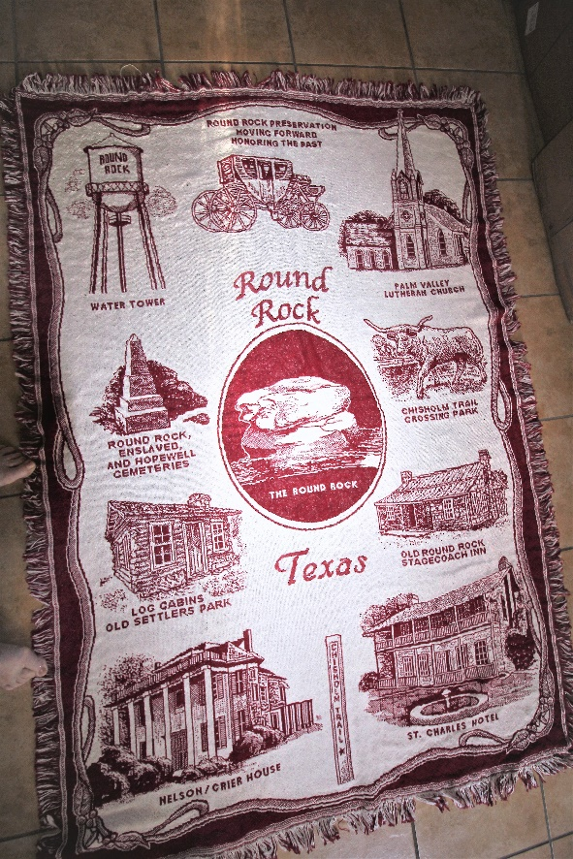
Order your throw now with a donation to RR Preservation for $65.00 to ensure you get a throw for the holidays. You can pay the donation and receive the throw when you pick up your throw in Round Rock or text 512-568-5875 for delivery options. The throws can also be ordered on-line at www.rrpreservation.org.
KENNEY FORT
In the news, one can read about the planned improvements the City of Round Rock has for Kenney Fort Blvd. Kenney Fort’s legacy is that Kenney Fort was the first settlement in Williamson County and its location was in Round Rock near what is now the swimming pool in the Concord at Brushy Creek Neighborhood. The Fort was built to protect the farmers and early day settlers from Indian attacks. The Fort was also the site where the Santa Fe Expedition began and the site where the Texas Archives War ended (both very important historical events in Texas history).
www.rrpreservation.org
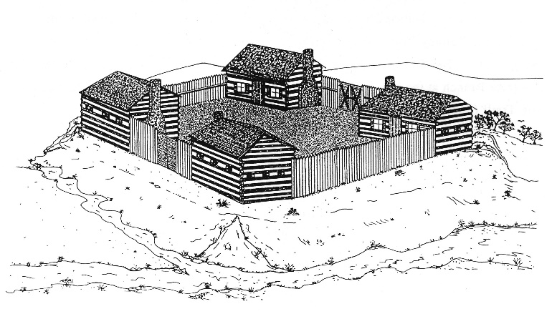
Sketch of what written records state Kenney Fort looked like in 1839
Today there are no visible signs of Kenney Fort except for a sign along Hwy 79 that speaks of Kenney Fort’s rich Texas history.
Another much smaller Kenney Fort sign can be found in the flower bed by the Concord at Brushy Creek Neighborhood Swimming Pool. School children donated the original sign at the site of Kenney Fort prior to Concord Neighborhood being built. At some time in history the original sign and the medal sign that flew over the site of Kenney Fort disappeared.
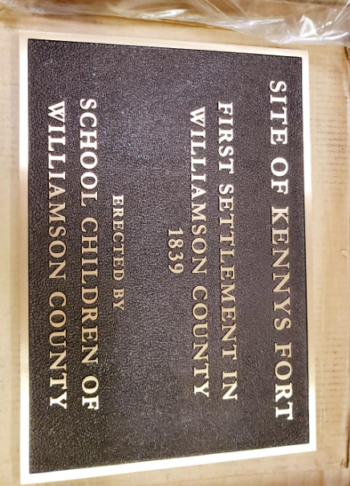
About a year ago the Concord Neighborhood had another sign made to replace the original sign that was donated by school children. The new sign was placed on the original base.
To ensure Round Rock does not, over time, forget the original location of Kenney Fort, Round Rock Preservation is conducting a fundraiser to place a historic marker at the original site in Concord at Brushy Creek Neighborhood to mark the original site of Kenney Fort.
RR Preservation needs $2,000 to pay for the sign. You can help make this possible by going to www.rrpreservation.org and making a donation. Frank Darr (RR Preservation Vice President) has established a Facebook page to help everyone keep up with the project. The new Facebook page is Kenney Fort Historic Site, Round Rock TX.

ROUND ROCK HISTORY LUNCH & LEARNS.
Event is free and open to the public.
If you work, take a lunch break to attend this event.

The topic for the upcoming quarterly Round Rock Brown Bag Lunch and Learn Program is History of Old Town Round Rock.
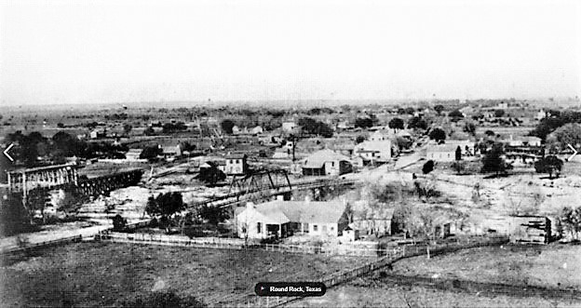
Old Town Round Rock
The speaker will be Kerstin Harding from the City Historic Preservation Office. The program will be Tuesday, September 13, from noon to 1 p.m. in the Grand Room of the Allen R. Baca Center. Attendees should bring their own brown bag lunch. Water and cookies will be provided.
We want to improve attendance at our events, so mark the calendar, bring a friend and take time to learn about the rich history of Old Town Round Rock. These events are also great for home schooled children.

LOCAL LEGEND SELECTIONS
The City Historic Preservation Commission will review Local Legend Nominations at their annual work session on September 20, 2022. They will also develop next year’s preservation goals for inclusion in the City of Round Rock Historic Preservation Plan within the City’s 2030 Comprehensive Plan.
The selection of this year’s proposed Local Legends will be forwarded to the City Council for a decision probably in late November. Nominees not selected remain on the consideration list for 5 years. Information about past Local Legends can be found on the City of Round Rock Website (Historic Preservation Office).

IS PRESERVATION IMPORTANT?
Recently I read a sign that stated most individuals believe saving significant historical buildings is important; however, too many of our historical buildings are lost in the U.S. every day, because most people believed someone else would preserve those historic assets.
If you believe in your heart historic preservation is important in Round Rock, please take the time to become a Round Rock Preservationist. Become a member of Round Rock Preservation or make regular donations to help preserve and protect Round Rock’s historic assets.
With your support, Round Rock Preservation will be your advocate for preservation within the City of Round Rock. RR Preservation can’t and doesn’t want to save every old building in Round Rock; however, it is important that the most significant historic assets within the City of Round Rock be preserved to help tell the history of our community.

RRP CONTACT INFORMATION
Mailing Address
Round Rock Preservation
PO Box 391
Round Rock TX 78680-0391

E-mail Address
roundrockpreservation50@yahoo.com

Telephone
(512) 568-5875

Facebook Pages
Round Rock Stagecoach Inn
Round Rock Preservation
Explore Round Rock
Kenney Fort Historic Site, Round Rock TX

Website
www.rrpreservation.org

Logo

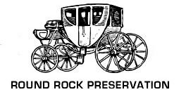
Moving Forward – Respecting the Past

