OPION D. Text with Clipart Brick (4X8) LAYOUT #2
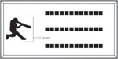

Clipart will be placed on the left side of the brick.
Number of characters is 12 per line, including spaces and punctuation. Logo height equals 2 inches.

OPTION E. Text with Clipart Brick (8X8) LAYOUT #3
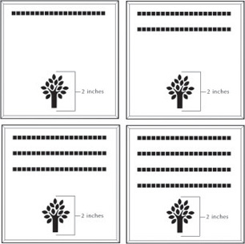

Clipart will be placed at the top of the brick and centered..
Number of characters is 20 per line, including spaces and punctuation. Logo height equals 2 inches.

