8X8 LAYOUT #3 Artwork layout for Custom Brick:
Corporate Custom logo can be used and positioned at the top of the brick.
Number of characters is 20 per line, including spaces and punctuation. Logo height equals 2 inches.

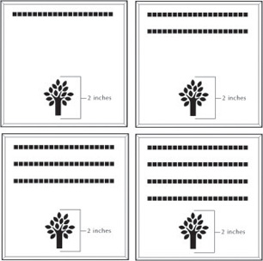
Artwork layout for free clipart -
ALL IMAGES APPLY TO THIS LAYOUT. All images can be used and are positioned at the bottom or top of the brick.
Number of characters is 20 per line, including spaces and punctuation. Logo height equals 2 inches.

