PRESIDENT’S NOTES. I am sad to report two of our Round Rock Preservation (RRP) Board Members (David and Shirley Tynan) are moving to Colorado in July. Kerstin Harding (a current board member) was voted by the board to fill the Treasurer vacancy when David Tynan departs. A partial audit for 2021 is currently being conducted prior to David’s departure. The Tynan’s are Charter Members of our nonprofit and will continue their membership from afar. Shirley Tynan was the person who asked me to help save the RR Stagecoach Inn from demolition when I first moved to RR in late 2012. Shirley Tynan’s request resulted in the relocation of the Inn and the formation of our nonprofit charity, RR Preservation. Shirley Marquardt, President

MAINTAINING SUCCESS. RRP relies on strong membership numbers and strong donations to support our small independent nonprofit.

RRP purposely keeps membership dues low, so a membership is affordable to everyone in the community. However, for a community population of 120,000, 28 members is a very low number of RRP Members.

RRP’s success depends on having members from the Round Rock community, who care about preserving Round Rock’s shared history and who want to preserve important historic landmarks and elements of our community.

Will you help bring in one new member to RRP by December 2021? Every membership helps. A membership application is attached to this newsletter. Our goal is to start the year of 2022 with a minimum of 50 members?

RRP also depends on donations to accomplish preservation projects (like the restoration of the RR Old Stagecoach Inn). We keep $2,000 in our general funds for operating expenses and place the remaining funds at the end of the year into our project funds. As of June 25, RRP has $46,553.15 in savings earmarked for the RR Stagecoach Inn Restoration Project and another $2,000.000 in checking. The Stagecoach Inn Project calls for $250,000 or more to accomplish that project.

Our donations are down over the last year because of COVID-19. Will you help by making a special donation? Every penny helps. Mail donations to Round Rock Preservation, PO Box 391, Round Rock TX 78680, or go to our website, www.rrpreservation.org and donate by PayPal. Our goal is to reach $50,000 in project funds by the end of 2021.

PALM HOUSE MUSUEM. The RR Chamber of Commerce closed the Palm House Museum on June 1, 2021, after a 44-year partnership with the Palm House Museum Association. The Chamber reports the Chamber’s mission does not include operating a museum.

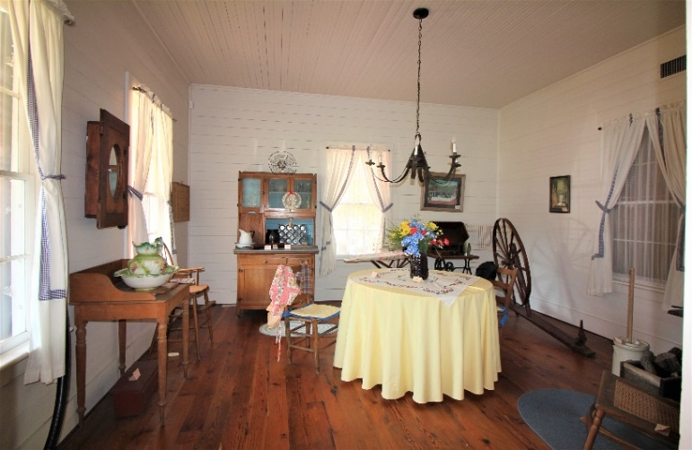
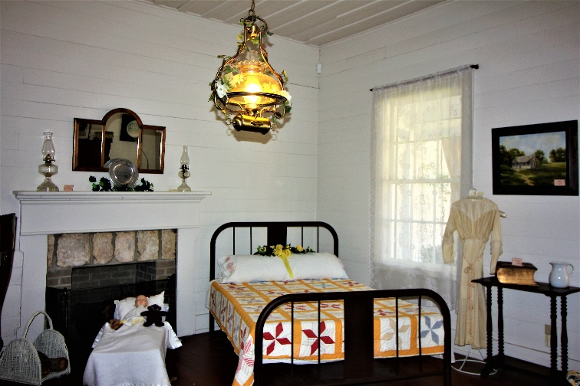

ROUND ROCK PRESERVATION
PO BOX 391, ROUND ROCK TX 78680-0391
Website: www.rrpreservation.org
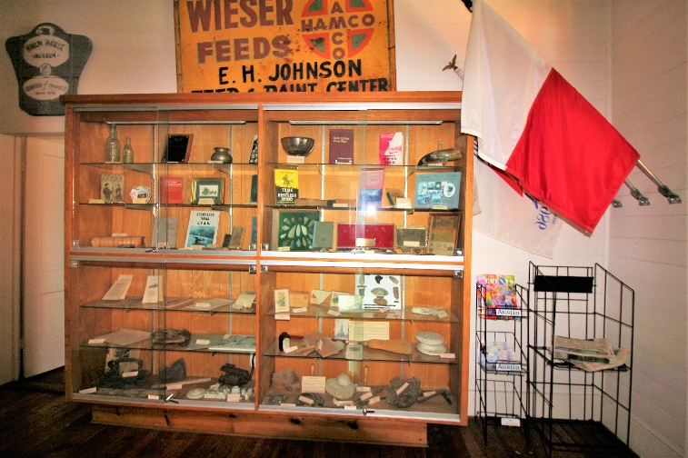
The goal of the Palm House Museum is to keep the museum collection of artifacts together in the City of Round Rock and to find a new home as quickly as possible for the Palm House Museum. If you have a solution for finding a new home for the Palm Valley Museum, please email, roundrockpreservation50@yahoo.com.

HISTORIC PRESERVATION MONTH. Historic Preservation Month during May was a major success. This year’s program was a partnership between RRP, the City of Round Rock (Historic Preservation Office, Arts & Culture Department, Baca Center, City Hall, RR Library), Palm House Museum Association, Williamson Museum, & Elroy Haverlah.
The Annual History Program webinar was digitally presented. Guest Speaker, Elroy Haverlah, presented “Anna Palm and Round Rock’s Swedish Immigrants.” *

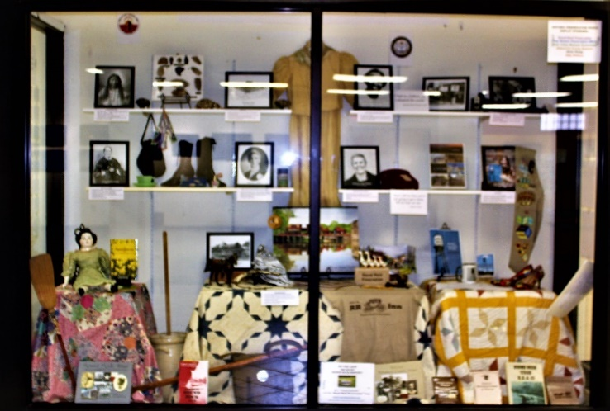
“Round Rock History through the Eyes of Women” Exhibit
at RR Library. Exhibit items were on loan from Palm House Museum, Williamson Museum & RR Preservation

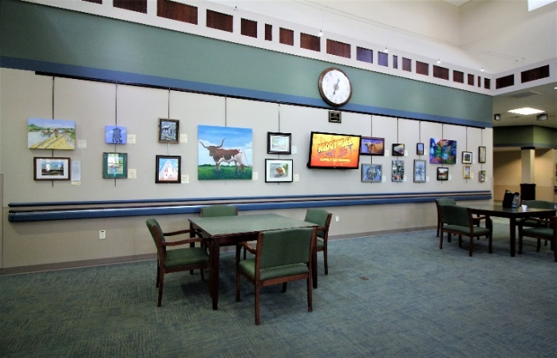
Art on Display by Center Art Club at RR Baca Center

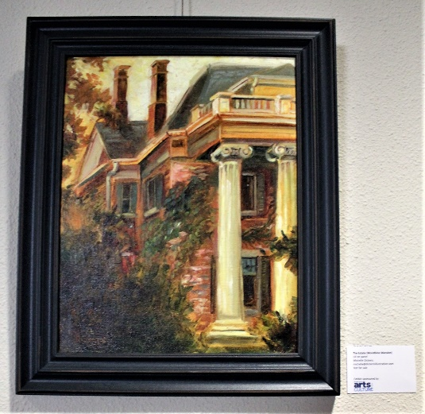
Art on Display by Round Rock Plein Art at City Council Chambers (City Hall).

e-mail: roundrockpreservation50@yahoo.com

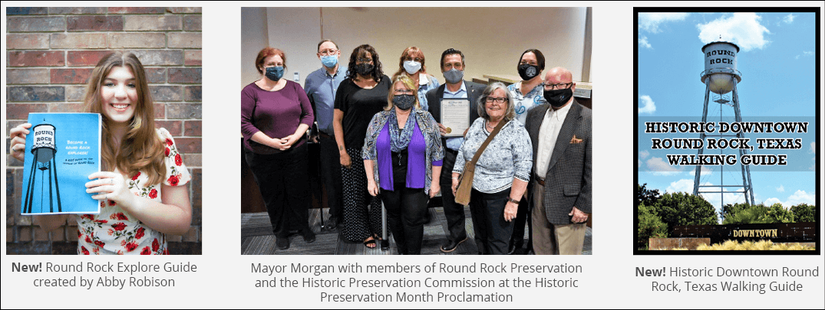
New Kids Guide to the History of Round Rock*
created by Abby Robinson.
Historic Preservation Month Proclamation*
New Historic Downtown RR TX Walking Guide*

*Viewing and copies available at https://ww.roundrocktexas.gov/historicpreservation/

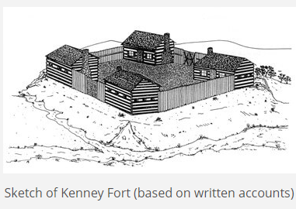

RRP KENNEY FORT SIGNAGE PROJECT. The original site of Kenney Fort is near the Round Rock Concord Neighborhood. A RRP Committee is developing the details so a historic roadside marker can be placed at the original site of Kenney Fort. Once details are developed, RRP will ask the community to help fund the sign through a special fundraiser.

FRANKLIN PARK SENIOR LIVING CENTER. On June 17th, Shirley Marquardt, RRP’s President, gave a special presentation at the Franklin Park Senior Living Center entitled “Round Rock: Our Home, Our Heritage, Our Past.” Approximately 20 residents attended the preservation.

www.rrpreservation. org

RRP LUNCH AND LEARN PROGRAM. RRP will resume its quarterly Lunch and Learn Program at the Baca Center. The Programs are free and open to the public.

Aug 17 (11:30 a.m. to 1 p.m.) RR History Series (Kenney Fort)
Nov 16 “ RR History Series
Mar 15 “ RR History Series

CITY TAX EXEMPTION PROGRAM. The City’s Historic Tax Exemption Program exempts 75% of the City’s portion of property taxes for owners of property with Historic Overlay Zoning. Property owners must apply each year. This year, 50 property owners applied; 49 property owners were approved. The 49 properties consisted of 36 commercial properties @ a tax offset of $101,653 with a mean average of $2,824 and 13 residential properties with a tax offset of $18,368 with a mean average of $1,413. The program provides an opportunity for property owners of historic properties to reinvest that money back into the care and maintenance of their historic homes. Exteriors of these properties are inspected each year and when maintenance issues occur, property owners have 1 year to correct the issue, or they lose the exemption the following year. This program helps retain the inventory of older historic properties within the City and keeps the city from losing historic structures due to demolition by neglect. Historic structures add value to our city’s ability to tell the city’s historic stories from the past and helps keeps the structures in place for the enrichment of our community and tourists alike.

CITY LOCAL LEGENDS PROGRAM. Each year the City receives many worthy nominations for its Local Legends Program. The program helps recognize contributions to Round Rock’s history in the areas of historic preservation, history, culture, diversity, and/or heritage. During May, RRP submitted two nominations to be considered as a Round Rock Local Legend. Elroy Haverlah prepared a nomination for Anna Palm.” Phebe Devol prepared a nomination for J.W. Wilbarger and his book “Indian Depredations in Texas.” J.W. Wilbarger is the historic owner of Round Rock’s Sansom House. RRP hopes at least one of our nominations will be selected, as both nominations will serve to tell Round Rock’s History. The 2021 Local Legends will be announced at a City Council Meeting in Nov/Dec 2021 timeframe.

RR STAGECOACH INN. Now that COVID-19 requirements have been lifted by the City, RRP has requested city leaders resume meetings with RRP to open discussion up again about the restoration of the RR Stagecoach Inn. RRP expects to meet with the City during early July.

Historic sites and properties are a great avenue to bring heritage tourists into Round Rock. The Heritage Trail West System and the Bathing Beach Project should be nearing completion during the end of the first quarter of 2022 and the City’s Hotel Occupancy Taxes (HOT) are slowing returning to normal.

During the July meeting, RRP plans to discuss establishing an annual percentage amount be provided from Hotel Occupancy Taxes (HOT) for Historic Preservation Restoration and Preservation Projects, as allowed by Texas Tax Codes. This funding, coupled with the donations collected by RRP, will begin movement forward for the restoration of the RR Old Stagecoach Inn.

In addition, the City of Round Rock owns the Sansom House and the Washington Anderson which need preservation efforts. An annual amount of HOT funds will help achieve the needs of current and future preservation and restoration projects and helps increase Heritage Tourism to the City of Round Rock.

RRP MONTHLY BOARD MEETINGS. RRP will continue meeting by Zoom for a few more months. If you would like a special invite to the meetings, send an e-mail to roundrockpreservation50@yahoo.com. We now meet by Zoom the second Tuesday of each month at 7 p.m.

More Art :
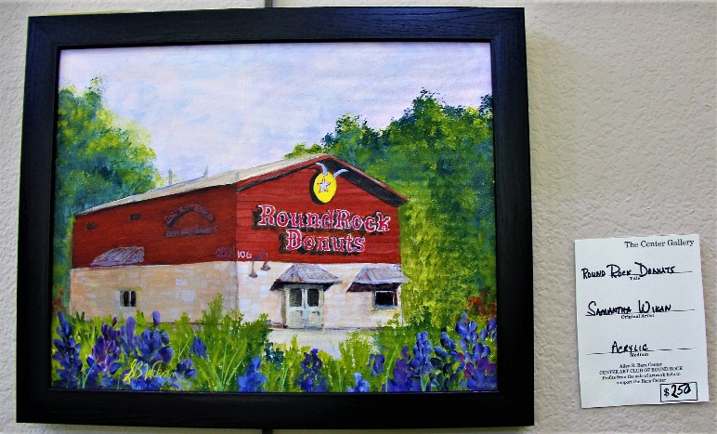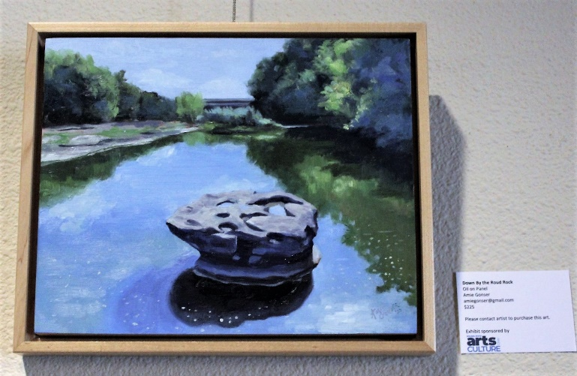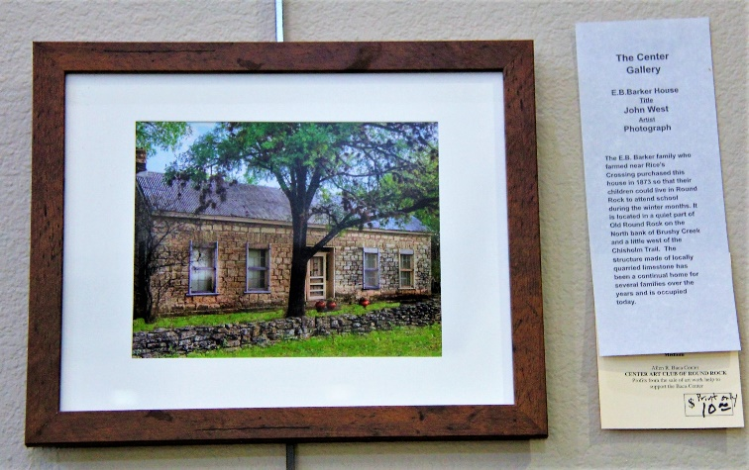

E-mail: roundrockpreservation50@yahoo.com

