A TOAST TO THE PAST
Round Rock Preservation (RRP) was founded 4 years ago on April 5, 2016. We have sponsored one major project since our organization formed. That project is saving, relocating, and restoring the Old Round Rock Stagecoach Inn.
The Inn is the oldest surviving structure within the City of Round Rock and was built 1848 by Joseph J. Harris. Our organization helped save the Inn from demolition through relocation and gave the City of Round Rock $2,500 for the relocation, paid $3,573 to establish an engraved brick history display at Bathing Beach Park (which is scheduled to be installed sometime in late 2021/early 2022). $250,000+ is needed for the restoration of the Inn and RRP has raised $43,000 for the restoration project. The restoration is awaiting needed funding from the City of Round Rock.
A collection of photos of the Old Stagecoach Inn from early 1900s until December 2020 follows:
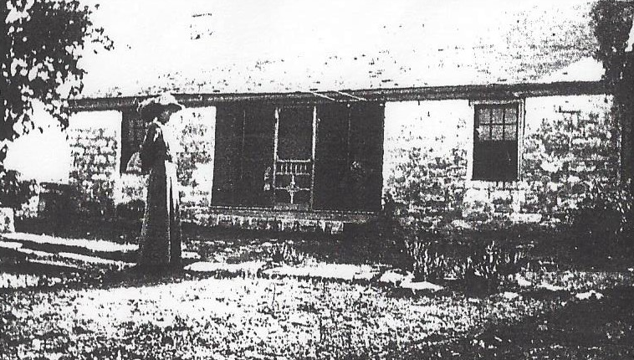
Early 1900s: A photo of Mrs. Tisdale
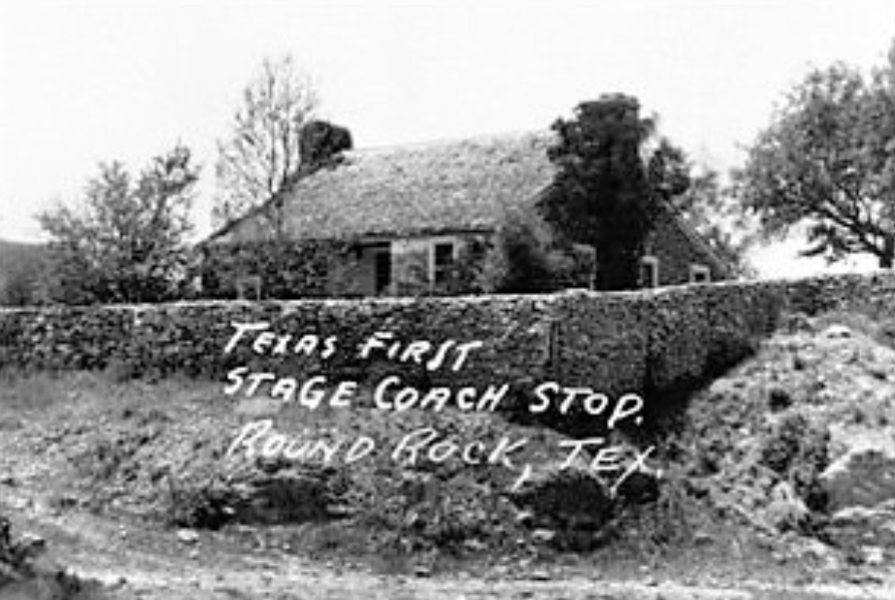
1930s Postcard
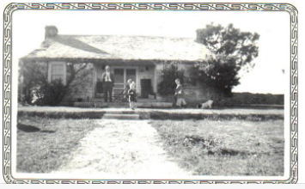
1940s. Addition added on backside of Inn.
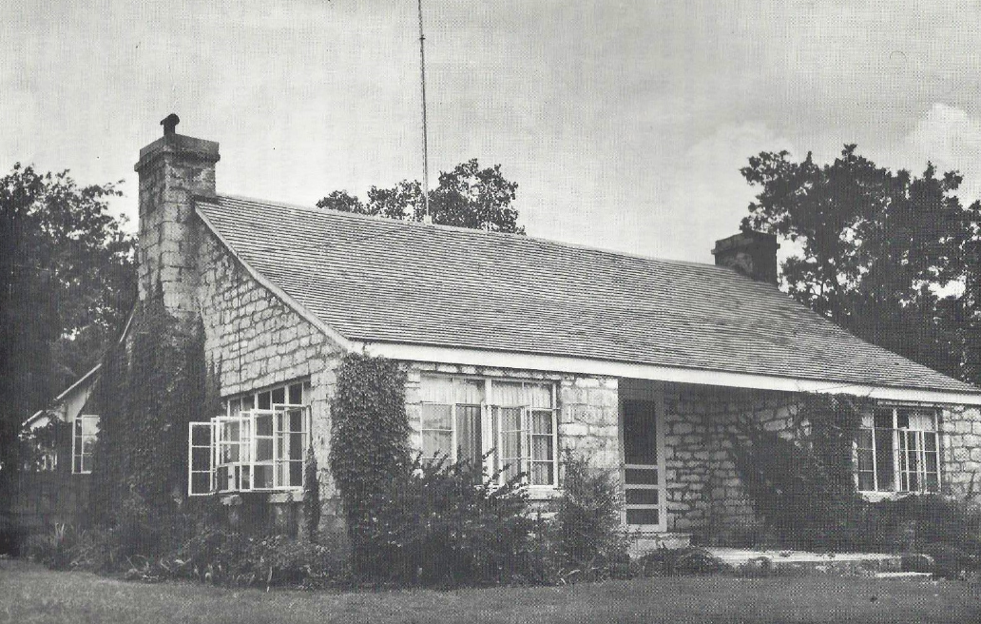
1960s. Windows changed. Addition added on south end as shown in next photo. 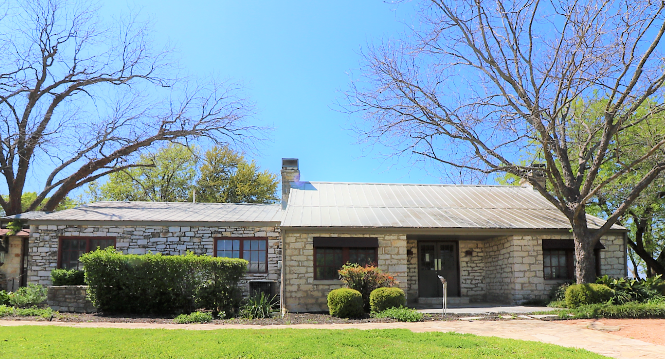
2016. Address prior to relocation
901 Round Rock Avenue
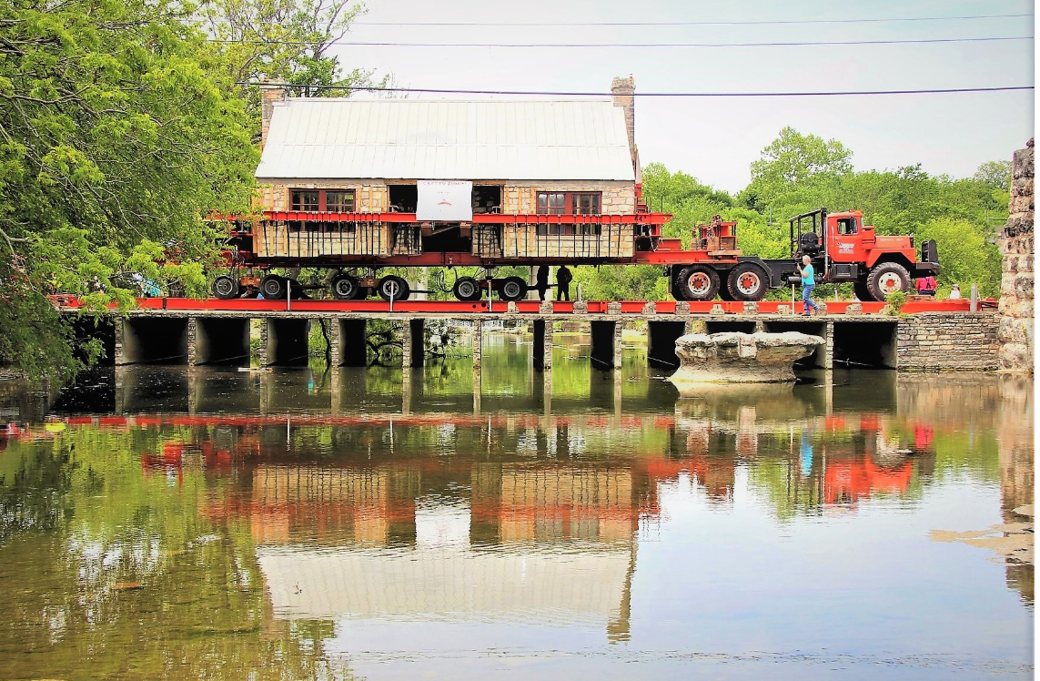
2018. Crossing Brushy Creek during Relocation
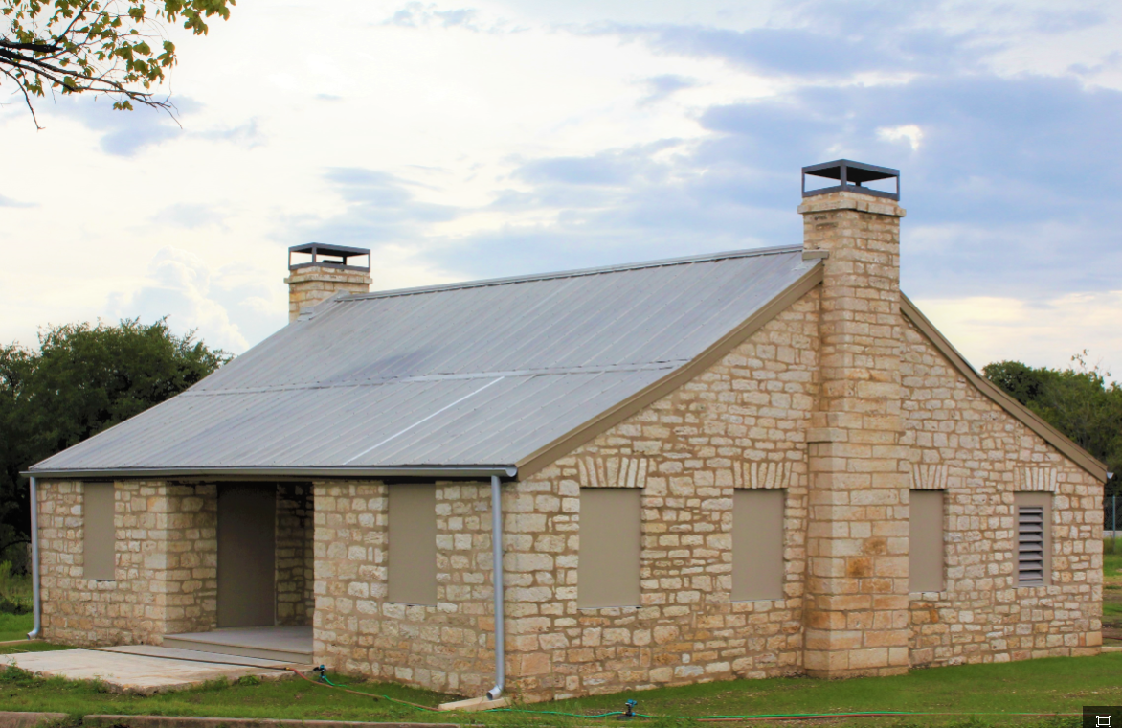
2018. New Address after relocation
750 Chisholm Trail Road

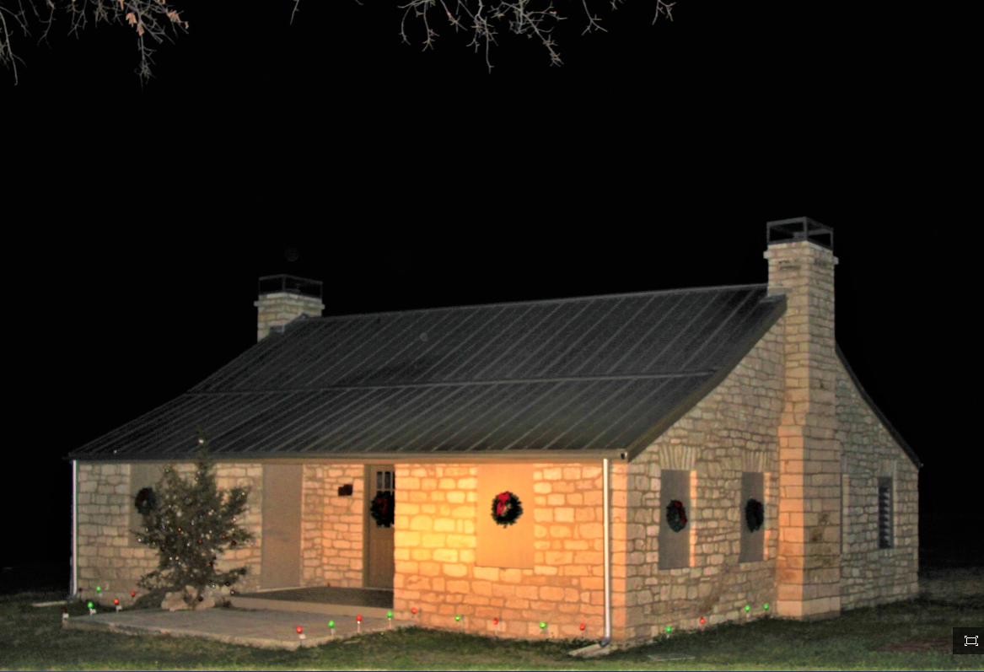
2019. Holiday Decorations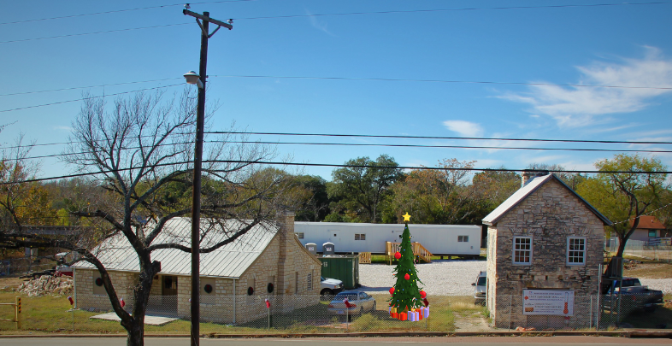
2020. Heritage Trail West & Bathing Beach Project begins.

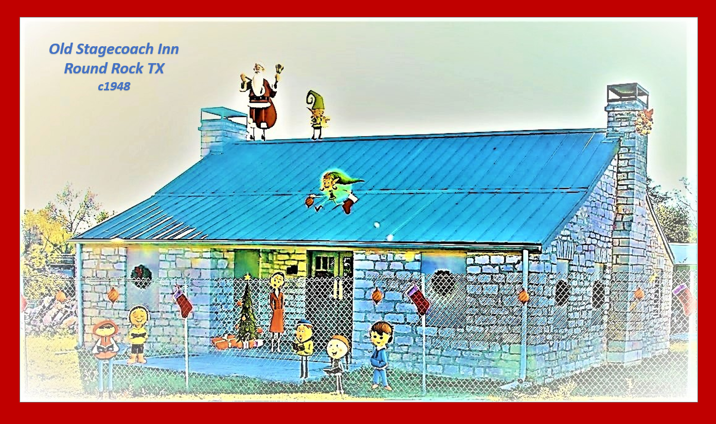

2020. Happy Holidays
LIST OF 2019 ACCOMPLISHMENTS

Grew restoration funds for Inn up to $43,000.

Published Stagecoach Inn Preservation through Relocation Photo Book. Currently for sale ($55.00).

Conducted Lunch & Learn Programs at Baca Center prior to COVID Pandemic.

RRP represented on:
City’s Historic Preservation Commission.
City’s Local Legend Committee.
Williamson County Historic Preservation
Commission.

Nominated Old Town as a Local Legend. Unsuccessful; however, will resubmit in 2021.

Began developing Kenney Fort Visibility Project

Met with City Leaders to discuss status of
RR Stagecoach Inn and its opening.

Coordinated with Chamber of Commerce & Palm House Association to develop possibilities for relocating artifacts to new home.

Developed “Explore Round Rock Adventure Kit” with walking stick, compass, canvas bag, Hiking Tour Guides of Round Rock & other items. Currently for sale ($35.00).

Worked to notify public on social media of historic buildings available for relocation to prevent demolition of those structures.

Posted news items to three Facebook sites:
Round Rock Stagecoach Inn, Round Rock Preservation, and Explore Round Rock.

Conducted monthly board meetings & annual membership meetings.

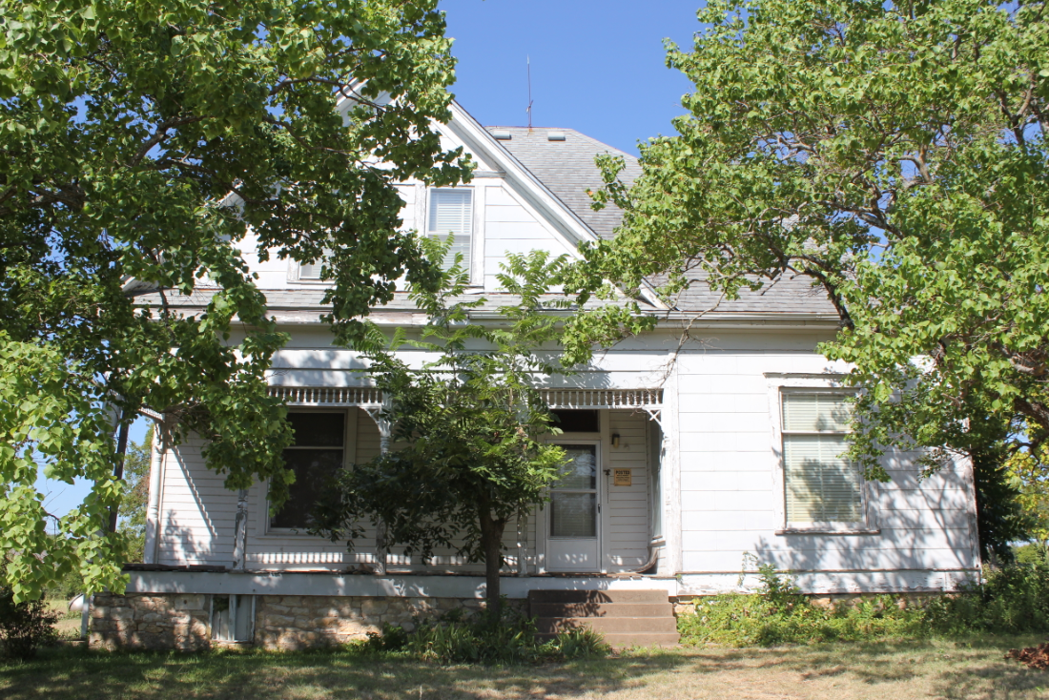
1907-1909 “May Home” Demolished
1001 University

RRP attempted to raise awareness about the endangerment and potential loss of the “May Home” at 1001 University by trying to find someone, who would relocate the home. Sadly, the timing was not long enough to find a new owner and move the home quickly. That home, along with its two barns, have been demolished. Prior to being owned by the May family, the home was owned by the Pete Peterson family.

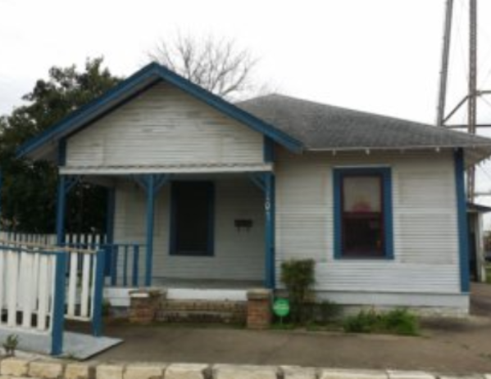
Circa 1930s Bungalow
103 W Liberty

This property is located near the Historic Water Tower and across the street from Round Rock Donuts store. At the present time, it appears media releases and RRP efforts have led to an interested party planning to move the bungalow to a property five blocks away. That action is now in the platting process; thus avoiding demolition of the historic home/business. Future plans are to re-purpose the bungalow into short-term rental property.

VISIBILITY OF KENNEY’S FORT HISTORY

Elroy Haverlah reached out to RRP about bringing visibility to the RR Community on the history of Kenney’s Fort. Frank Darr, our Vice President, has volunteered to take the lead on this project. This project is just starting. We expect progress to be made during 2021. If anyone has any vintage photos of Kenney’s Fort, please share those photos with us.

We also want everyone to share information about endangered historic buildings within the City of Round Rock, as well as submitting ideas for future preservation projects. Just e-mail us at roundrockpreservation50@yahoo.com.

EXPANDING BOARD OF DIRECTORS

If you have a heart for preserving history, for preserving significant historic places of Round Rock, and have time to volunteer 2-3 hours per month to help RRP expand our organization’s capabilities to accomplish preservation-related actions in Round Rock, RRP invites you to serve as a volunteer director on the Round Rock Preservation Board of Directors.

To apply for a position on the RRP Board of Directors, send an e-mail to roundrockrpeservation50@yahoo.com.

Provide RRP a short bio and state why you want to serve on the board. RRP will add your name to the ballot to be voted on by the members in February at the Annual Membership Meeting. If you have questions, text Shirley Marquardt, 512-568-5875. Just leave a message and Shirley will call you back.

www.rrpreservation.org

ANNUAL MEMBERSHIP MEETING

Mark your calendars. The Round Rock Preservation Annual Membership is scheduled virtually by Zoom for Wednesday, February 10, 7 p.m. More information will be provided to you in early January 2021.

HOLIDAY TRADITIONS

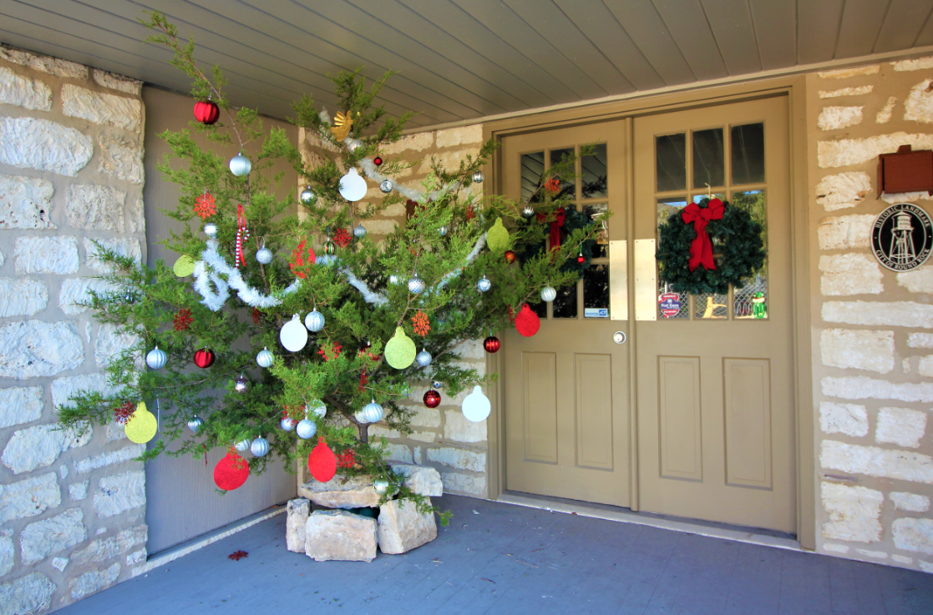
2020 Holiday Tree
Keeping traditions alive at the Inn.

In early days, it was a tradition with the pioneers to cut down a live tree to decorate a home for the holidays. This live tree, located on the porch at the Inn, was donated from land owned by Phebe Davol. Phebe lived in the Inn as a child.

The Inn has two separate chimneys where owners could hang up the children’s Christmas stockings. One chimney is on the north side of the Inn and another on the south side of the Inn. I imagine many a memory was made around those two fireplaces and during the holidays. If we could only go back in time and listen in, what family stories we would uncover.

Harold Richards, a former owner of the inn (1941-1957), was highly allergic to cedar. Harold always brought the live tree into the Inn on Christmas Eve to prevent him getting cedar fever. When the children woke up on Christmas Day, they always found the tree fully decorated.

HOLIDAYS GIFTS AVAILABLE
ITEMS AVAILABLE AT
www.rrpreservation.org
or call 512-568-5875

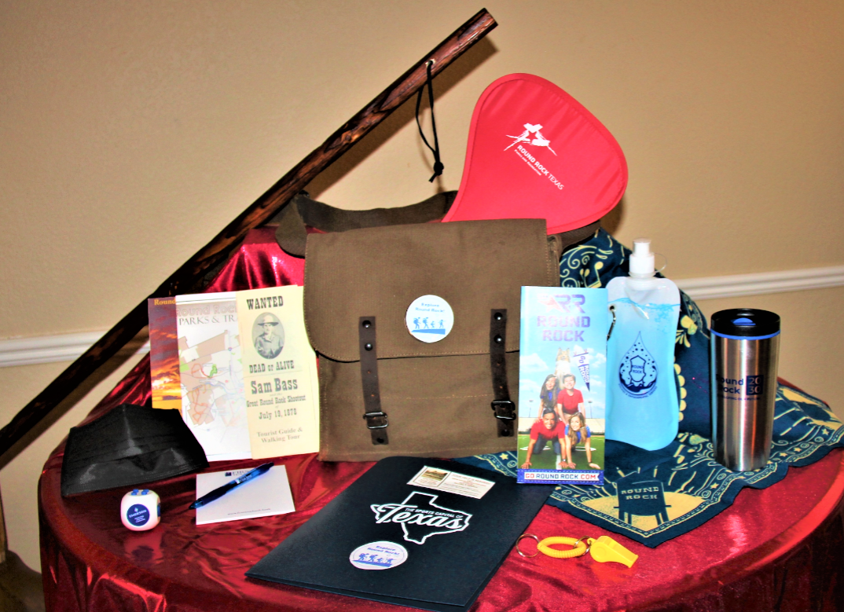
Explore Round Rock Adventure Hiking Kit $35.00 (Includes stick, bag, hiking guides, etc.)

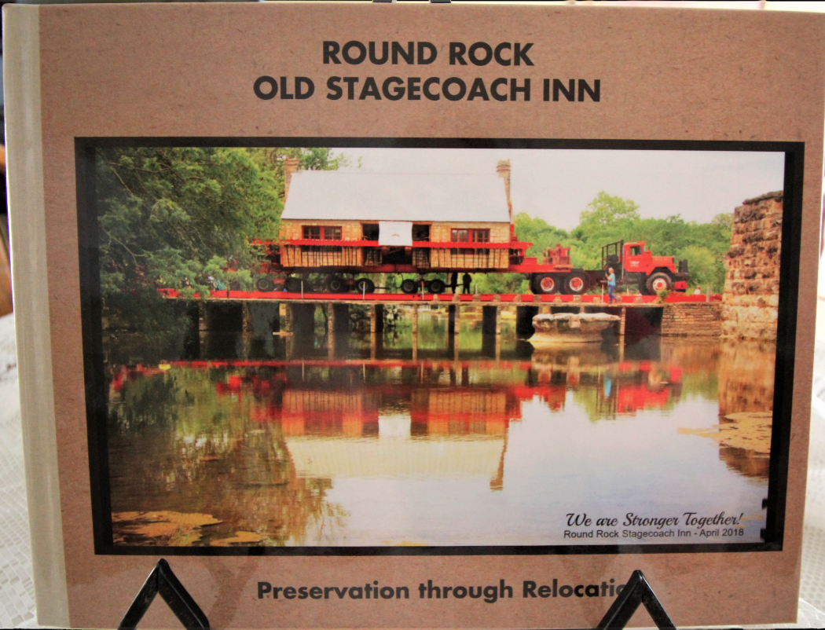
Photo Book (Inn Relocation) - $55.00

Canvas Print - $130.00
(Inn crossing Brushy Creek)

2020 BOARD OF DIRECTORS
Shirley Marquardt, President
Frank Darr, Vice President
Judy Anderson, Secretary
David Tynan, Treasurer
Kerstin Harding
Richard Parson
Blythe Plunkett
Tina Steiner
Shirley Tynan

HAPPY NEW YEAR!!!

