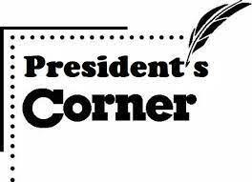

RRP President’s Corner. On January l, 2023 during the holidays in Colorado, I slipped on ice and broke both bones in my right leg. I had surgery on January 4th and I am finally back in Round Rock and on the path to recovery. It feels so good to be home again and with my preservation family. Members of the RRP board of directors kept RR Preservation running during my absence by mailing out tax exemption letters and conducting a Lunch and Learn Program at the Baca Center. My sincere appreciation to our loyal and talented board members. Job well done. Our board looks forward to growing our preservation efforts in the City of Round Rock during 2023.
Shirley Marquardt, President

RR Preservation (RRP) Annual Meeting. The RRP annual meeting will be held virtually on Tuesday, April 25, from 7-9 p.m., using Google Meet. The meeting is open to RR Preservation members and individuals interested in historic preservation within the City of Round Rock.
The meeting will cover the status of our 501c3 Public Charity Nonprofit Organization, toast our 2022 achievements, and announce our 2023 Awardees. Members will cast their votes to elect RR Preservation board members for 2023-2025. RRP will e-mail a link for the meeting to our members. Other guests can request a link to attend the meeting by sending a request to roundrockpreservation@gmail.com.
RR Lunch & Learn History Program. The RR Lunch and Learn History Program is co-sponsored by RRP and the City of Round Rock Historic Preservation Office. The programs are held at the RR Allen R. Baca Center (302 Bagdad Ste. 2) on the second Tuesday of each quarter. Our programs are held in the Grand Room from noon to 1 p.m. There is open seating; no RSVPs required. The programs are free and open to the public. Come, bring your own Brown Bag Lunch and get to know the history of Round Rock. Our 2023 Schedule includes:

May 9: William Walsh & the Round Rock White Lime Company (Presenter: Chris Walsh)
Aug 8: Williamson County Cemetery Restoration Volunteers (Presenter: Joe Plunkett)
Nov 14: The Quick Family History in Round Rock (Presenter: Larry Quick)

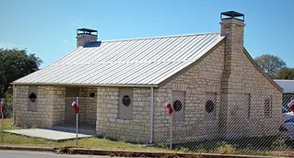
RR Stagecoach Inn Restoration Project. The road to completion of the RR Stagecoach Inn Project has been filled with starts and stops. On Feb. 28, 2023, four Requests for Bids were received by the City of Round Rock. The bids ranged from $720,000.00 up to $1,230,000.00. Since the bids were significantly higher than expected, RRP is awaiting a decision from the City of Round Rock on its status. The Parks Department informed us last week the city has given the go ahead on the project. They will propose City Council select HCS, Inc., a Waco contractor, for the project at the City Council meeting on Thursday, April 13. The proposed bid from HCS is in the amount of $714,371.00.

Local Legends Nominations. 2023 RR Local Legends nominations are now being accepted by the City of Round Rock Historic Preservation Office within the City’s Planning & Development Services Department. The deadline for submission of a nomination by the public is May 31, 2023.
The purpose of the program is to recognize individuals, families, places, businesses, institutions, publications, and/or organizations that have had a lasting impact on the culture, development, and history of Round Rock. Local Legends Nominees must have a direct connection to the founding of the city or help tell the story of the City of Round Rock, particularly related to its early history, preferably at least 30 years ago. For detailed information on the program and the application form, go to locallegends@roundrocktexas.gov or call 512-218-5428.
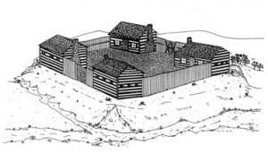
In 2022, two RRP nominations were selected as Local Legends: James Wesley Wilbarger (property owner of the land where the Sansom House is located at 750 Chisholm Trail Road and author of the book, “Indian Depredations in Texas”) and Round Rock White Lime Company and the Walsh Family (largest employers in Round Rock prior to Dell Technologies and the 1904 World Fair Bronze Medal Winner for the best white lime in the U.S.).
Sketch of Kenney Fort based on written accounts

Kenney Fort Signage. The RRP project to raise funds to purchase and install a Kenney Fort Sign at its original location in Round Rock is still on-going. For more information or to donate, go to https://www.rrpreservation.org/kenney-fort-projec t.
RR Preservation Awards Program. RRP is creating a Round Rock Historic Preservation Awards Program and will seek nominations from the public for the 2023 RR Historic Preservation Awards. The public can nominate an individual(s), a business, or a contractor who, during the calendar year of 2023, greatly improved a historic property within the City of Round Rock, who saved a historic property from demolition, who accomplished a youth project related to historic preservation, or have published a preservation related book or article on preservation. The public can also nominate a person, an organization, or a group of individuals who worked or volunteered to help implement historic preservation programs and projects within the City of Round Rock, Texas over 2023 or a period of years.
Nominations will be due to Round Rock Preservation, PO Box 391, Round Rock TX 78680 no later than 31 December 2023. Nominees selected to receive an award will be announced during 2024 Historic Preservation Month (May 1-31, 2024). The Round Rock Historic Preservation Awards Program Information and nomination forms will be available at www.rrpreservation.org beginning June 1, 2023.

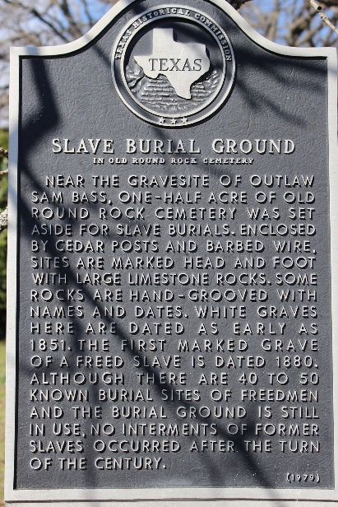

Round Rock Cemetery Clean Up. Two board members from Round Rock Preservation participated in the annual Round Rock Cemetery Clean Up on April 1, 2023. Tina Steiner, who chairs the Slave Cemetery Cleanup Committee, worked with Frank and Ann Darr and others to clean up the Slave Cemetery area of the Old Round Rock Cemetery.

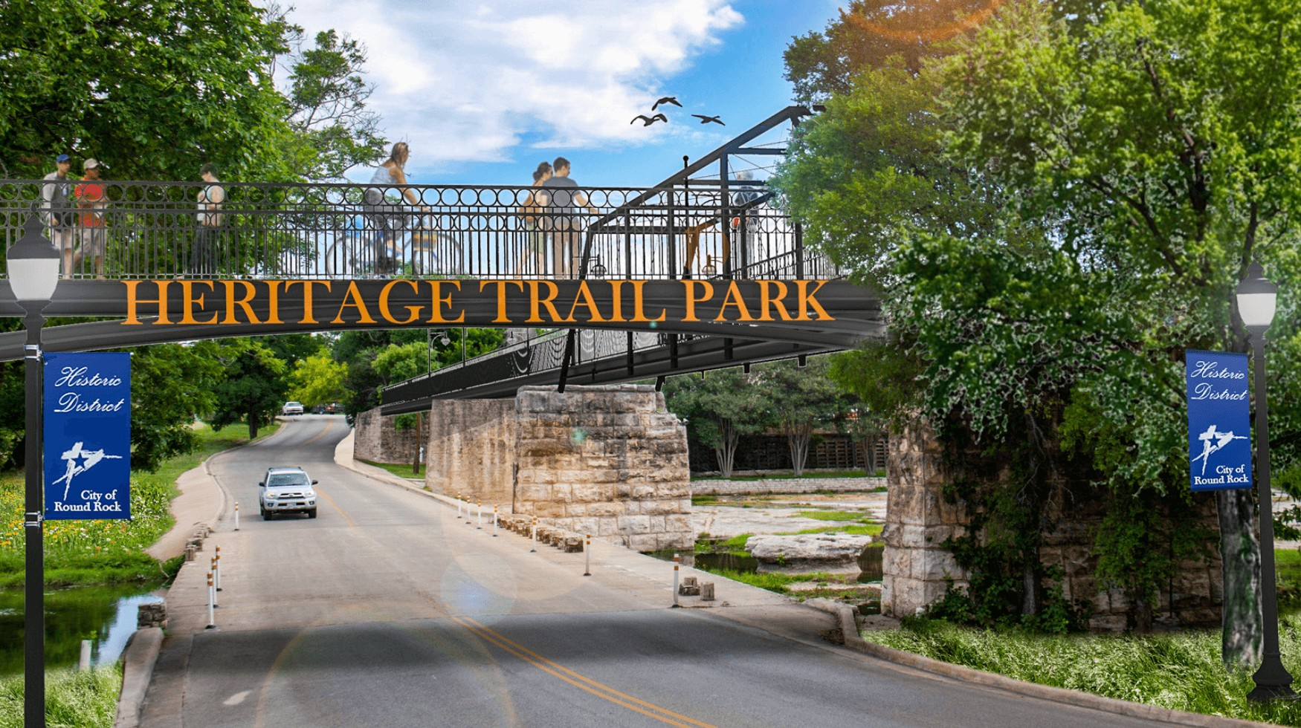

Heritage Trail West Project (Bathing Beach & Engraved Bricks). This project was delayed last year because the contractor, Botkin Prime Construction Co., filed for bankruptcy as work began in January 2021 at a cost of $7.3 million. On Feb 9, 2023, a new contract was initiated with Patin Construction for $19.5 million to finish the project including the Bathing Beach, RRP Engraved Bricks Installation, Chisholm Trail Park, and Memorial Park. The project starts at Bathing Beach Park on Chisholm Trail Road and runs to Mays Street. This project does not include the restoration of the RR Stagecoach Inn.

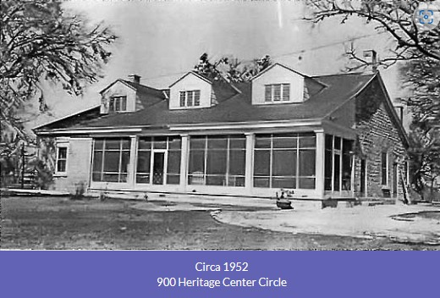

Washington Anderson House. The City of Round Rock plans to make maintenance repairs to the historical Washington Anderson House located at 900 Heritage Center Circle. This home is a state designated historic structure. The house is owned by the City of Round Rock and the repairs will probably include a new roof and replacements of rotted wood on the windows, doors, and porch. The Chamber of Commerce is considering making the Washington Anderson House their temporary home while they await completion of the renovations on the new home at the Old RR Library.

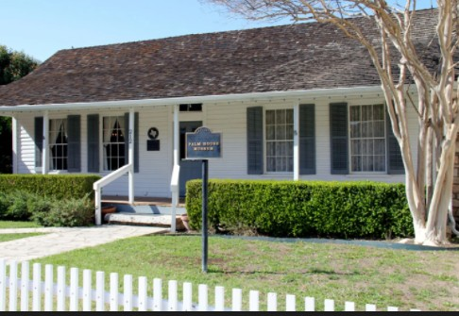

Palm House Museum. The City of Round Rock has plans to relocate the Palm House Museum (where the RR Chamber of Commerce currently makes its home at 212 E Main Street) back to Old Settlers Association near its original site. The historic structure holds a Texas Historic Designation. The expected new location is behind the Palm Mansion and in front of the old country store. The move is expected to take place in July 2023 or later. The Palm family artifacts will be relocated to the museum, and it is expected the Williamson County Museum will conduct special events in and near the museum after the relocation.
As part of the old library’s renovation, the City of Round Rock will turn the space to the west of the old RR Library into a breezeway between city hall and the new library. The Chamber of Commerce is expected to move into the old library once restorations at the old library are completed.

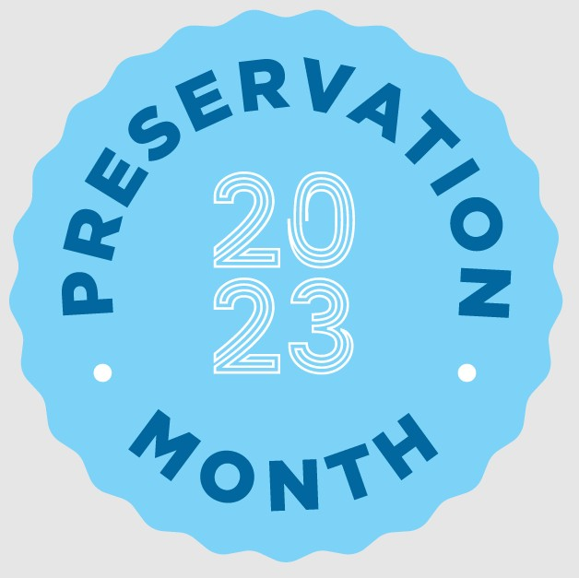

2023 Historic Preservation Month (May 1-31); National Trust Theme: People Saving Places.
Round Rock Theme: People and Places: Historic Round Rock “Palm Valley” Story.
Apr 27 HP Month Proclamation Presentation (City Council Meeting)
Apr 29 National Historic Marker Day
May 1-31 Art Display by the Center Art Club Display (Allen F. Baca Center)
May 1-31 History Display in the Adult Display Cabinet (RR Library).
May 3 Historic Preservation Information Table (Music on Main, Prete Plaza, 7-9 p.m.)
May 6 Pioneer Day (Old Settlers Park)
May 9 RR History Program (William Walsh & the RR White Lime Company (Baca Center Noon to 1 p.m.)
May 17 Historic Preservation Information Table (Music on Main, Prete Plaza, 7-9 p.m.)
May 20 City of Round Rock History Tour Downtown (10 a.m.) The tour is free though it requires registration and Round Rock Preservation will accept donations. The route is just over a mile and will be taken at a leisurely pace. The tour covers the Downtown Historic District and nearby neighborhoods beginning and ending at Centennial Plaza. Details and signups will be posted on the city’s Historic Preservation website by the end of April at www.roundrocktexas.gov/historicpreservation.

If you believe in your heart historic preservation is important in Round Rock, please take the time to become a Round Rock Preservationist. Become a member of Round Rock Preservation or make regular donations to help preserve and protect Round Rock’s historic assets.
With your support, Round Rock Preservation will be your advocate for preservation within the City of Round Rock. RR Preservation can’t and doesn’t want to save every old building in Round Rock; however, it is important that the most significant historic assets within the City of Round Rock be preserved to help tell the history of our community.

RRP CONTACT INFORMATION
Mailing Address
Round Rock Preservation PO Box 391
Round Rock TX 78680-0391

E-mail Address
roundrockpreservation@gmail.com

Telephone
(512) 568-5875

Facebook Pages
Round Rock Stagecoach Inn Round Rock Preservation Explore Round Rock
Kenney Fort Historic Site, Round Rock TX

Website

www.rrpreservation.org

