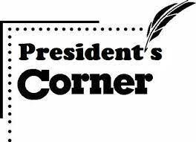

RRP President’s Corner.

Outgoing President’s Comments
I am honored to have served as President of Round Rock Preservation since its founding in 2016 and to have led efforts to save and restore the Round Rock Stagecoach Inn since 2012. As I step down as President, I transfer the opportunity to Judy Anderson to lead our Nonprofit Charity, RRP. I know Judy will continue my efforts to grow historic preservation efforts within the City of Round Rock and will accomplish many new preservation projects in the future. I will continue to be a voice for historic preservation efforts within the City of Round Rock, as I continue serving RRP as a member of the RRP Board of Directors and as an RRP Officer. I thank each RRP Board Member and each RRP Member and supporter for working alongside me to expand preservation initiatives in Round Rock. You can be proud of your many great accomplishments. I ask you to continue your support of RRP, Judy Anderson, and me in my new roles as Secretary and Membership Chair.
Shirley Marquardt, Outgoing President

Incoming President’s Comments
After serving as Secretary and Membership Chair for RRP since 2019, I have agreed to step up to serve RRP as President. Shirley Marquardt is not going anywhere. We have many projects under way, and she will be actively involved in seeing them to completion. Our level of gratitude for Shirley’s committed leadership, determination and tireless energy cannot be overstated. Hers will be difficult shoes to fill but I am looking forward to getting started. RRP’s success in convincing city leaders to save the Stagecoach Inn from destruction is credited to Shirley’s leadership and tenacity. RRP has made great strides in educating the community about historic properties, personalities and preservation and I look forward to continued success leading our Nonprofit Charity events and projects. I will appreciate your continued support and your words of thanks and appreciation to Shirley Marquardt for her amazing vision.
Judy Anderson, Incoming President

Vote to make sure the Stagecoach Inn renovation includes adequate parking and restrooms. The City of Round Rock, Texas, has two contracts underway during 2023 that impact the Stagecoach Inn location. One contract will build the Bathing Beach Park as a part of the Heritage Trail West Project and the other contract will restore the Round Rock Stagecoach Inn so the oldest historic structure in Round Rock can be opened for use.
At a recent City Council meeting, Parks and Recreation stated that Parks plans to use the Round Rock Stagecoach Inn for a lot of different purposes and that the only thing the building doesn’t have is a restroom at this specific time. Parks also stated the two contracts do not include a public restroom facility or public parking inside the Inn/Bathing Beach Park area.
Parks indicated that the closest restroom is down the trail system at Memorial Park. The use of Memorial Park restroom facility does not address the needs of individuals attending meetings or events at the Inn/Bathing Beach Park. Access to Memorial Park by foot from Inn/Bathing Beach Park area requires crossing Chisholm Trail Road and is a long 10+ minute walk (one way) from the Inn/Bathing Beach Park area, plus another10+ minute walk to return to the Inn/Bathing Beach Park.
There are limited existing parking spaces in the Chisholm Trail Crossing Park lot which is located at the top of the hill on the south side of Brushy Creek for visitors to that park. The number of parking spaces at the Chisholm Trail Crossing Park does not meet the parking needs for physically challenged individuals or the number of individuals needing parking spaces for meetings and events at the Inn/ Bathing Beach Park.
The final phase of the restoration will include a new tin roof and new wood floors, doors, and windows. Because of the small interior, Parks decided not to include an interior restroom inside the Inn. The restoration does include a handicap ramp by the back door.

Round Rock Preservation recently updated and submitted two Local Legend nominations for the 2023 Awards expected in the Fall. One was for Old Town Round Rock and the other was for Chris and Linda Perez who owned and operated Chris & Linda’s Barber and Beauty Shop, located at 903 and 905 Sam Bass Road in Old Town Round Rock opened for business in November 1966 as a dual business.

Old Town is important to the City’s founding. The first permanent settlement in Round Rock was the Village of Brushy in the early 1840s. The village of Brushy was later renamed Round Rock. With the arrival of the railroad in 1876, this area became known as Old Town Round Rock as growth of Round Rock extended east to the train tracks. The new development of Round Rock became known as New Town Round Rock. Today New Town Round Rock is known as Downtown Round Rock. While both areas were listed on early day maps, eventually both areas were referred to as Round Rock. The early-day pioneers living in Old Town allowed growth and movement eastward to expand the growth of Round Rock.

Both Chris and Linda Perez promoted and helped with Frontier Days and Fiesta El Amistad, as well as the White Cane Society (Lion’s Club program for the Blind). The City of Round Rock awarded them the “Service to Mankind” award in 1979. The Perez’ were asked to be foster parents for children from the Texas Baptist Children’s home when overflow conditions occurred. Over the years they provided fostering services in their home for twenty-three children.
The Perez’s ran the United Way services for needy families out of the shop and took donations as well. They assisted Ms. Robinson establish Murphy’s Nursery which is now Round Rock Garden Center. All these endeavors were to get Old Town Round Rock thriving again.

One of Round Rock Preservation’s goals is to submit one or two nominations for this honor each year. If you have suggestions on future nominees, contact us at roundrockpreservation@gmail.com.

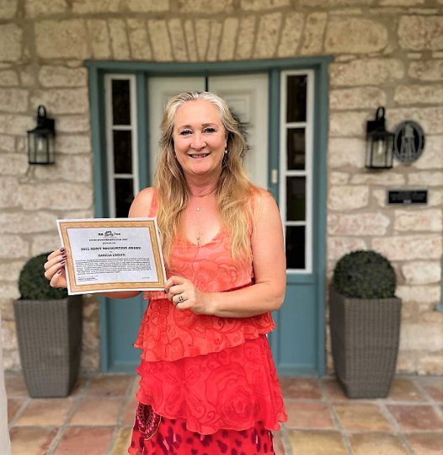
Isabella Linssen received the "2022 RRP Merit Recognition Award" to honor her work in restoring the historic Owen House and Complex. The Owen House was the former St. Charles Hotel at 8 Chisholm Trail Rd. They gave our board a tour and what a treat!

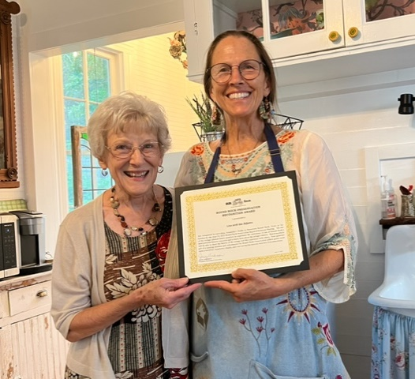

Lisa Adams saved the servants’ quarters from the Woodbine Mansion from being demolished by the new owners and made it available for rent through Airbnb.

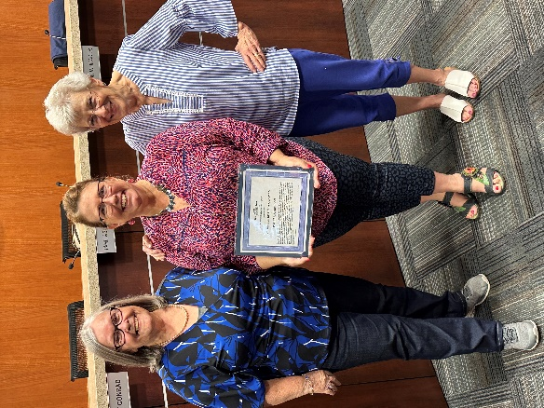

Pamela Anderson received our Volunteer of the Year Award at this year’s annual meeting.

Recap on Historic Preservation Month May was a busy Historic Preservation Month for us. We had a table at Music on Main, hosted the City of Round Rock Walking History Tour, had Boy Scouts involved in an Eagle Scout Project clean historical marker signs and had displays at the Round Rock Library and Baca Center. See the festivities below!

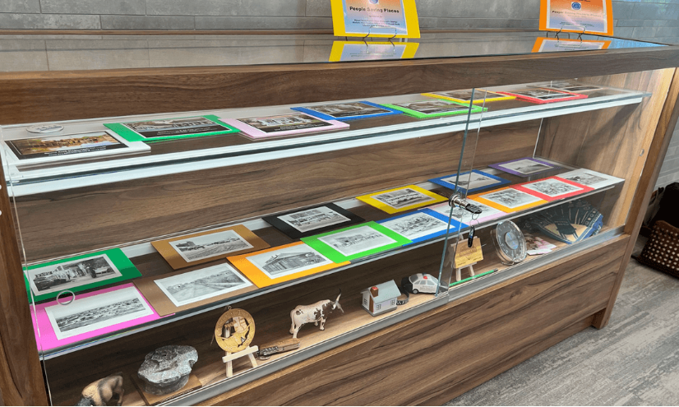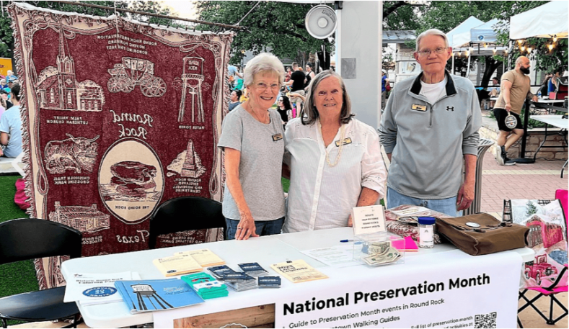
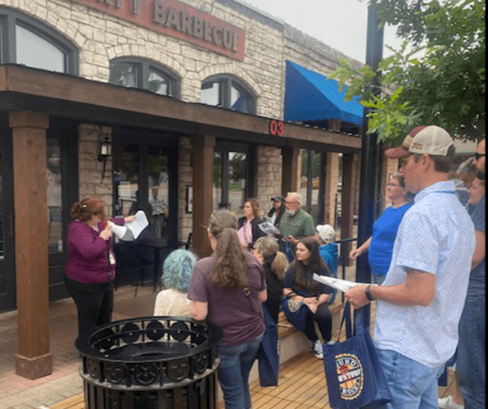
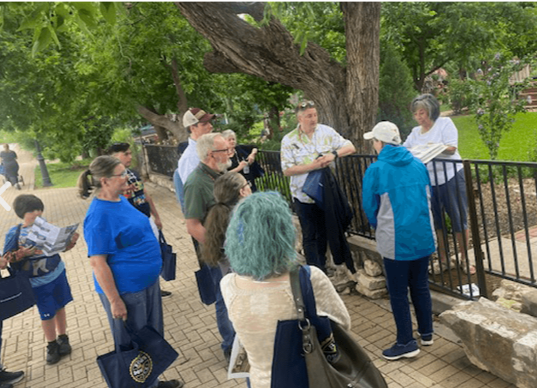

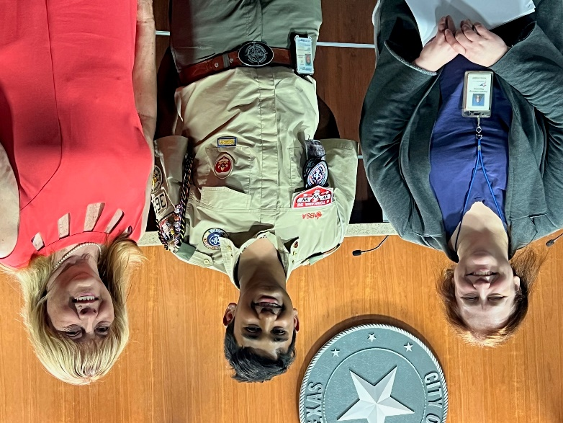

Eagle Scout Project
Samir Srinivas completed his Boy Scouts of America Eagle Scout Project by supporting Historic Marker Day in Round Rock by leading Boy Scouts from Troop T365 in cleaning 30 historic markers and repainting two markers in front of the Old Broom Factory and the Washington Anderson House here in Round Rock.

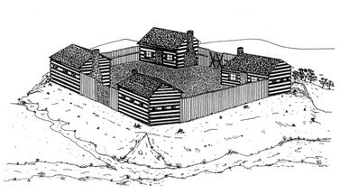
Kenney Fort Visibility Project
RRP is continuing to finalize the format for the Kenney Fort Historic Sign that will be installed at the original site of Kenney Fort. We are also working with vendors to obtain cost estimates. In the meantime, there is still time for you to help fund this project. Visit www.rrpreservation.org or mail in your donation to RRP, PO Box 391, Round Rock TX 78680

The original site of Kenney Fort is located within the Concord at Brushy Creek Neighborhood. Kenney Fort is important to the history of Round Rock because the site was involved with both the Texas Archives War and the Santa Fe Expedition. Check out our Facebook Page, “Kenney Fort historic site, Round Rock Tx. “

RR Lunch & Learn History Program. The RR Lunch and Learn History Program is co-sponsored by RRP and the City of Round Rock Historic Preservation Office. The programs are held at the RR Allen R. Baca Center (302 Bagdad Ste. 2) in each quarter of the year. Our programs are held in the Grand Room from noon to 1 p.m. There is open seating; no RSVPs required. The programs are free and open to the public. Come, bring your own Brown Bag Lunch and get to know the history of Round Rock. Our 2023 Schedule includes:
Aug 8: Williamson County Cemetery Restoration Volunteers (Presenter: Joe Plunkett)
Nov 14: The Quick Family History in Round Rock (Presenter: Larry Quick)

Members of RRP
A huge welcome goes out to our new members that joined RRP in 2023.
- Sandy Holman
- Mark Mayfield
- Janis Thompson
RRP also sends out a “Thank You” to our members, who have renewed their memberships this year. Each membership provides RRP the support we need to continue preservation projects and history programs within the City of Round Rock.

If you believe in your heart historic preservation is important in Round Rock, please take the time to become a Round Rock Preservationist. Become a member of Round Rock Preservation or make regular donations to help preserve and protect Round Rock’s historic assets.
With your support, Round Rock Preservation will be your advocate for preservation within the City of Round Rock. RR Preservation can’t and doesn’t want to save every old building in Round Rock; however, it is important that the most significant historic assets within the City of Round Rock be preserved to help tell the history of our community.

RRP CONTACT INFORMATION
Newsletter Editor
Blythe Plunkett, RRP Board Member
Mailing Address
Round Rock Preservation PO Box 391
Round Rock TX 78680-0391

E-mail Address
roundrockpreservation@gmail.com

Telephone
(254) 289-0626 Judy Anderson
(512) 568-5875 Shirley Marquardt

Facebook Pages
Round Rock Stagecoach Inn Round Rock Preservation Explore Round Rock
Kenney Fort Historic Site, Round Rock TX

Website

www.rrpreservation.org

