PRESIDENT’S CORNER
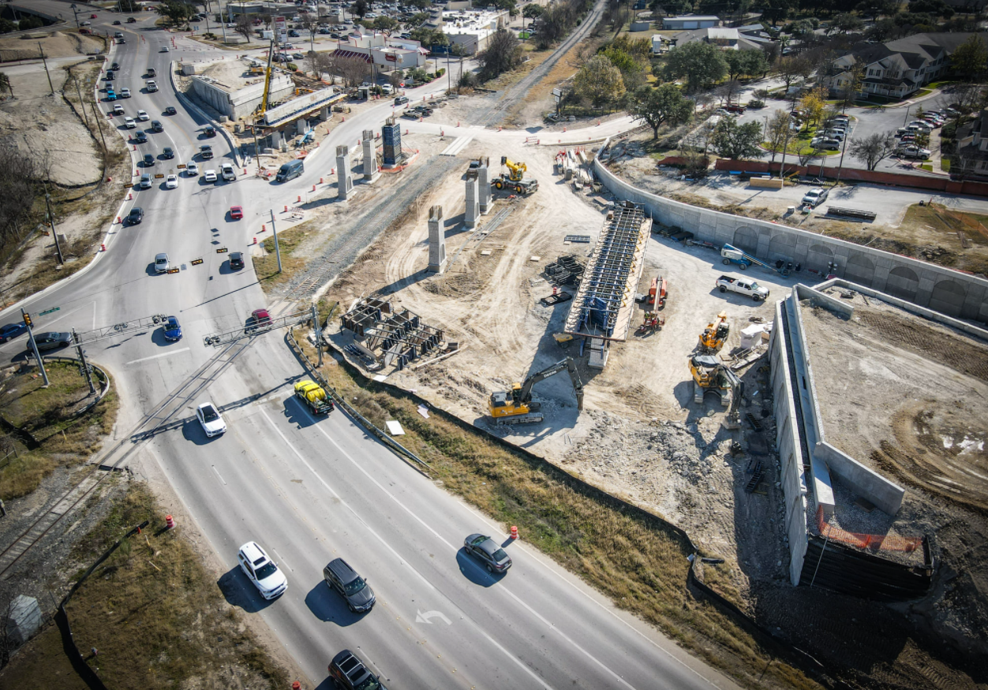
City Photo: RM 620 Road Safety Project

The Old Round Rock Stagecoach Inn was relocated from 901 Round Rock Avenue to 750 Chisholm Trail Road in April 2018 to avoid being demolished by the RM 620 Road Safety Project. The Inn is awaiting interior restoration before the Inn can be placed back into public use. The photo above captures the former site of the RR Stagecoach Inn, which was originally located at the SW corner of RM 620 & Chisholm Trail Road. The new overpass will be located directly over the original site of the Inn

If you travel down Chisholm Trail Road just north of the RM Road Project, you can see work on the Heritage Trail West Project has shut down around the Chisholm Trail Crossing Park and the Old Stagecoach Inn areas.

During the holidays, the City’s Parks Department informed Round Rock Preservation (RRP) the contractor for the Heritage Trail West/Bathing Beach Project has filed for bankruptcy. The City has begun legal proceedings with the contractor. This is the first time a bankruptcy has occurred with a Parks Project and Parks has no idea how long that process will take before they can start the process to obtain a new contractor to complete the work on the Heritage Trail West Project/ Bathing Beach Project.

In the meantime, RRP engraved bricks are being produced and will be shipped to Round Rock Parks Department during January 2022. Parks will receive and store the engraved bricks until the bricks can be installed by a new contractor.

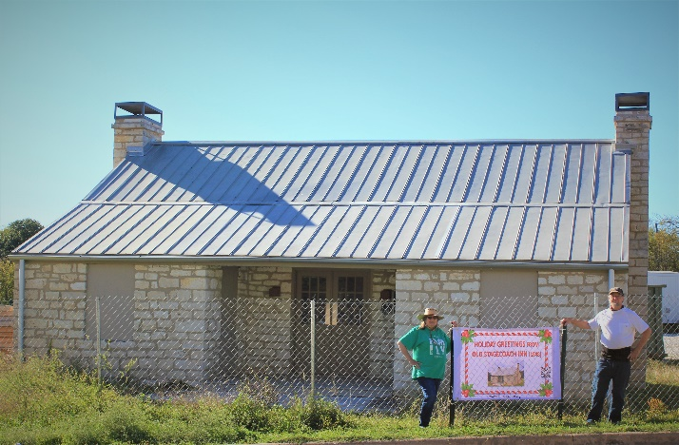
Ann & Frank Darr (RRP VP) installing the RRP Holiday Greetings Sign located in front of the construction fence at the RR Old Stagecoach Inn.

During the holidays, RRP met with Brooks Bennett, Assistant City Manager, to obtain answers about the future status of the RR Stagecoach Inn. Brooks informed me, he agrees the Architectural Design for the Interior Restoration of the Inn (which will take 6-8 months to complete) should begin immediately. In that way, the designs will be shelf-ready when the city is ready to select the contractor for the restoration work on the Inn.

Brooks also ensured me that if the legal process for the Heritage Trail West Project proves to be an extended process, he sees no reason to wait to select a contractor for the restoration of the Old Stagecoach Inn and the City would start the Stagecoach Inn Project (even though the Heritage Trail West Project is not complete).
With these facts in mind, it is possible the Stagecoach Inn’s interior design process could be completed during 2022 and the Stagecoach Inn Restoration Project could begin as early as 2023.

Brooks assured RRP the $300,000 budgeted this year from Hot Funds are intended only for the restoration of the Inn and those funds will be carried forward from year to year. He also assured me those HOT funds are controlled by the City Manager and will not be made available for other uses within the city.

The new 3% annual Hot Funds budgeted for Historic Preservation Projects are intended for upkeep, maintenance and restoration needs on city-owned historic properties (such as the Stagecoach Inn, Sansom House,
Washington Anderson House, etc.) This is a positive step; since in the past, the City has not designated recurring appropriations for upkeep of city-owned historic properties. This action ensures in the future no city-owned historic properties will be lost because of neglect.
Shirley Marquardt, RRP President

Round Rock Preservation will host its annual membership meeting on Tuesday - February 8, 2022 – 7 p.m. – by Zoom. The link for the zoom meeting will be forwarded to members prior to the meeting. Meeting is open to persons interested in becoming members of RRP.

CALL FOR NEW MEMBERS

Become a new member of RRP prior to February 1, 2022, and you will receive an 18-month membership for the price of a one--year membership. An annual individual membership is only $30.00. See all membership options on our website at www.rrpreservation.org. Remember obtain a free six month membership by joining RRP prior to February 1, 2022.

RRP HISTORY THROWS

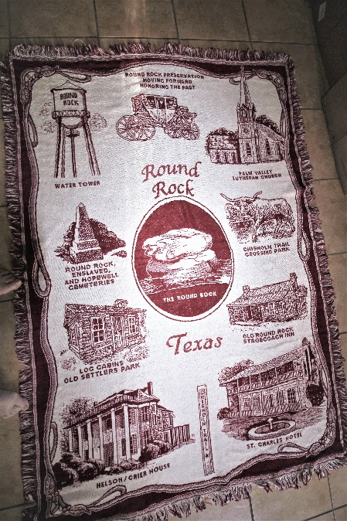
RRP History Throw

The 2021 holidays are over; however, winter is just getting started. RRP has a solution to keep you warm and wrap you up in RR History. Act quickly to obtain a RRP History Throw. We are almost sold out. Only 14 throws are left, so you must hurry if you want one. They are a real bargain at $60.00 each.
The remaining throws are available at www.rrpreservation.org or text (512) 568-5875 for details.

RRP will order more throws only when we have sufficient advance orders to justify the re-order. Remember the price for throws from the contractor went up 4% or more on Jan 1, 2022. If RRP re-orders, the cost of RR Throws will go up according to increased costs from the contractor.

ANNUAL BOARD ELECTIONS

It’s time for RRP board elections. RRP members, who want to serve on our the RRP Board of Directors, please text me or call me at (512) 568-5875 by February 1. We currently have two vacancies on our board of directors, because two of our former directors moved to Colorado during 2021 (David and Shirley Tynan).
Consider serving on our RRP Board of Directors. Election of new officers and/or re--election of current officers will take place during the annual Members Meeting on February 8.
Board members running for re-election for 2022/2023 are Shirley Marquardt and Blythe Pluckett.

www.rrpreservation.org

SHIRLEY MARQUARDT

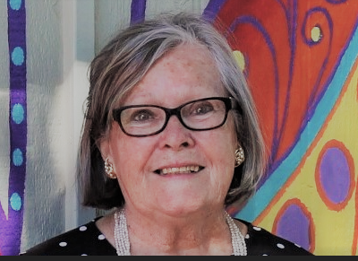

Shirley Marquardt is founder and President, RRP. She retired at Fort Hood in 1998 as a GS-12 Organizational Effectiveness Consultant, after working 34 years with the federal government and has a MS Degree (Human Resource Development) from University of Central Texas.

Shirley has been involved with historic preservation programs since 1998; first in Oklahoma and then in Round Rock. Shirley moved to Round Rock in 2012 and immediately began efforts to save the Round Rock Old Stagecoach Inn from demolition. She founded the non-profit organization, RRP, in 2016 and has served as President, RRP, since its founding.

Shirley contributes her successes in preservation to the amazing team members that have worked with her to preserve Round Rock’s rich heritage and history.

Every day Shirley advocates for the preservation of Round Rock’s most significant historic structures and objects. Historic Preservation is her passion.

BLYTHE PLUCKETT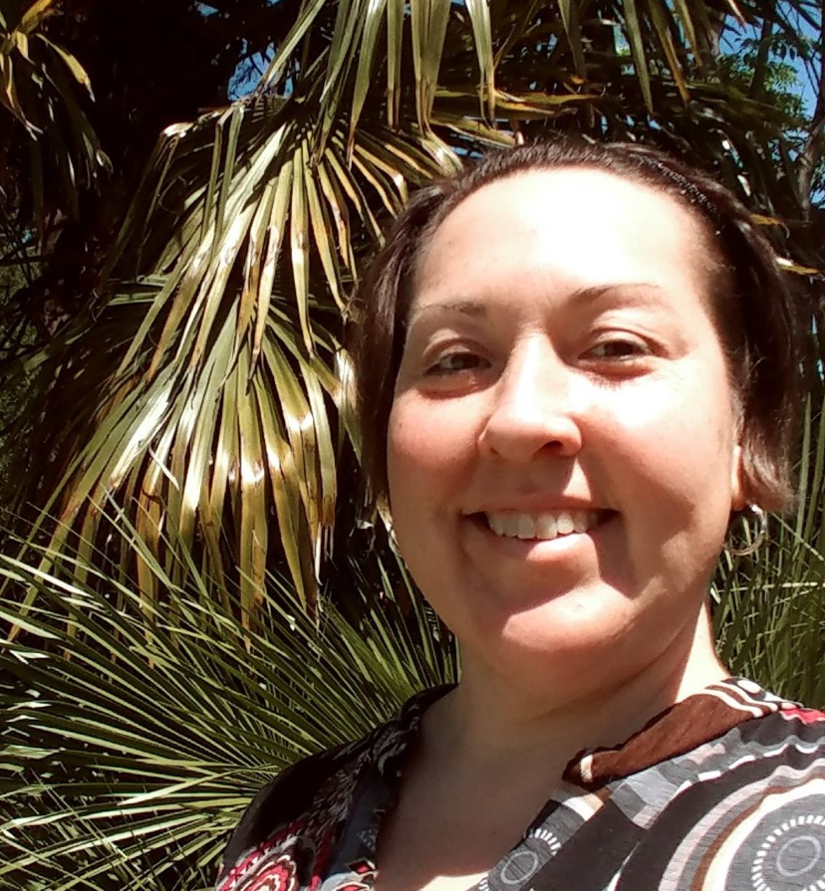
Blythe Plunkett was born in Austin but has called Round Rock home since kindergarten, graduating from RRHS. She went back to work in the construction industry last year for Biggs Plumbing as an Operations Specialist after a 10-year hiatus employed in the non-profit sector.

Blythe worked for Mobile Loaves & Fishes and subsequently Project Transitions as a Facilities Manager, Case Manager and Volunteer Manager during those years. She still serves on the boards of non-profits centered around homelessness, but is excited to be more involved in her own community of Round Rock

Having worked in and around construction and land development, Blythe became interested in preserving important aspects of communities. While working for a local civil and structural engineering firm, Blythe served as the representative at Round Rock City Council and Planning & Zoning meetings. She learned a lot about the civil processes around development and preservation.

Blythe believes keeping Round Rock the charming community her family has enjoyed for almost 40 years is of utmost importance, so it can be enjoyed for years into the future.

Blythe is an amazing artist and loves painting concert posters, friends, and pets.

KENNEY FORT – ARCHIVES WAR – SANTA FE EXPEDITION

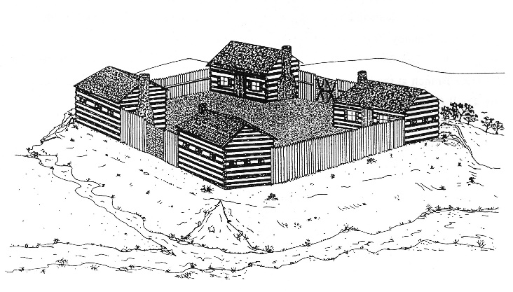
Round Rock Preservation kicked off a Kenney Fort Awareness Campaign at a Lunch and Learn Program at the Baca Center on November 16, 2021. The presentation was entitled “Kenney Fort – Archives War - Santa Fe Expedition.” The speakers were Elroy Haverlah and Frank Darr.

RRP’s goal is to install a historic marker at the original site of Kenney Fort within the Concord Neighborhood on Brushy Creek sometime during 2022. RRP also wants to create a small prototype model of Kenney Fort that can be taken to the schools for educational uses. You can help by gifting a donation for the Kenney Fort Projects at www.rrpreservation.org.

In addition, Frank Darr and Elroy Haverlah are available to present this program to any group in Round Rock. E-mail request to roundrockpreservation50@yahoo.com.

Frank Darr (RRP VP) is researching writings published in a book 100 year ago on this topic and he plans to expand this new information into his briefings. More to come.

JAMES CORNELIUS (JIMMIE) RICHARDS, SR. (89)

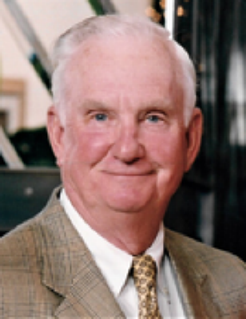

RRP is saddened by the death of Judy Anderson’s Uncle Jimmie, James Cornelius Richards, Sr.

Jimmie passed away on December 21, 2021 in Decatur. Jimmie grew up as a child living in the Old Stagecoach Inn and was the first major contributor to the RRP Old Stagecoach Inn Relocation/Restoration Fund.

Throughout the past several years, Jimmie provided details about the Inn from his memories living in the Inn. Jimmie’s information helped RRP and the City of Round Rock Historic Preservation Office capture the real story of the Inn, which has proven to be priceless in recording the Inn’s rich history. Jimmie will be missed by the RRP Preservation Community.

ROUND ROCK PRESERVATION
BOARD OF DIRECTORS
Meetings:
2d Tuesdays, 7 p.m. Zoom

Shirley Marquardt, President
Frank Darr, Vice President
Judy Anderson, Secretary
Kerstin Harding, Treasurer
Phebe Davol, Director
Sylvia Forbes, Director
Richard Parson, Director
Blythe Pluckett, Director
Tina Steiner, Director

Round Rock Preservation
PO Box 391
Round Rock TX 78680-0391

www.rrpreservation.org

Text: (512)-568-5875
rOUNDROCKPRESERVATION50@YAHOO.COM

BREAKFAST AT URBAN EATS

Shown in the photo below are RRP board members, who attended a Directors’ Breakfast at Urban Eats this past week.

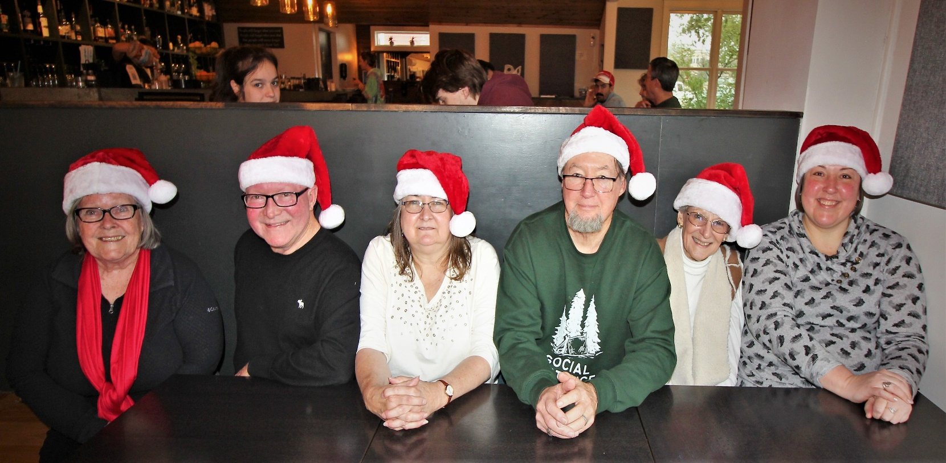

(L-R) Shirley Marquardt (Pres), Richard Parson (Dir), Ann Darr (Mbr), Frank Darr (VP), Judy Anderson (Secy), and Blythe Pluckett (Dir). Missing are: Kerstin Harding, Phebe Davol, Tina Steiner, & Sylvia Fores.

STAGECOACH ROUTES
PART OF ROUND ROCK HISTORY

There were 31 Stagecoach Routes in Texas from 1861 forward according to the Texas Almanac. Several of those routes traveled through Round Rock, Texas, and made several stops in Old Town Round Rock, to include at Round Rock’s Old Stagecoach Inn and possibly the Sansom House. Our dream is to acquire a historic stagecoach to place on display by the Inn and the Sansom House.

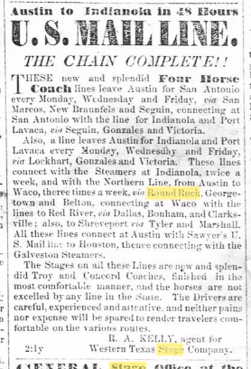

This early day newspaper article describes the Troy and Concord Stagecoaches being used along the stagecoach routes through Round Rock.

www.rrpreservation.org

CONCORD STAGECOACH

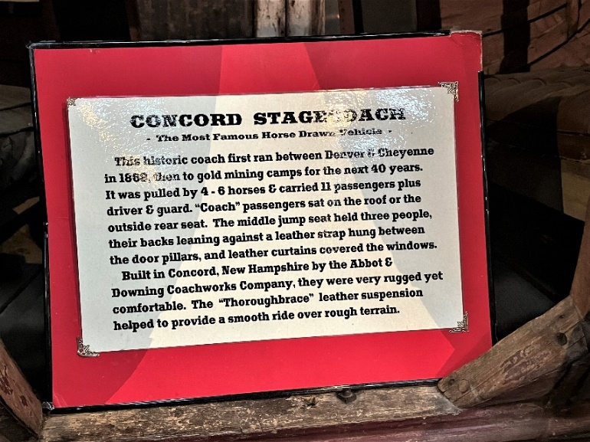 Image 13 total people traveling across undeveloped land for miles and miles on one stagecoach. Would you do it?

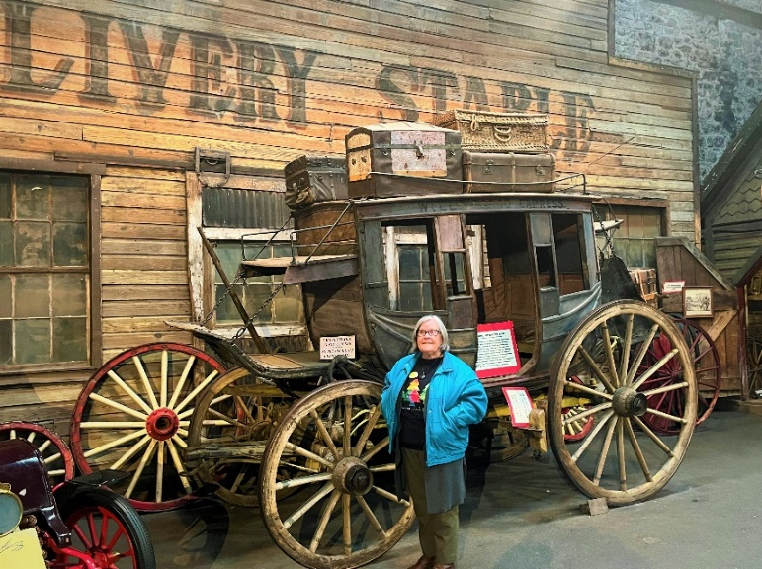 Shirley Marquardt stands beside a Concord Stagecoach in the Ghost Town Museum in Old Colorado City, Colorado. Back wood wheels are 5’ tall (same height as Shirley!)

WHEELS OF THE WEST

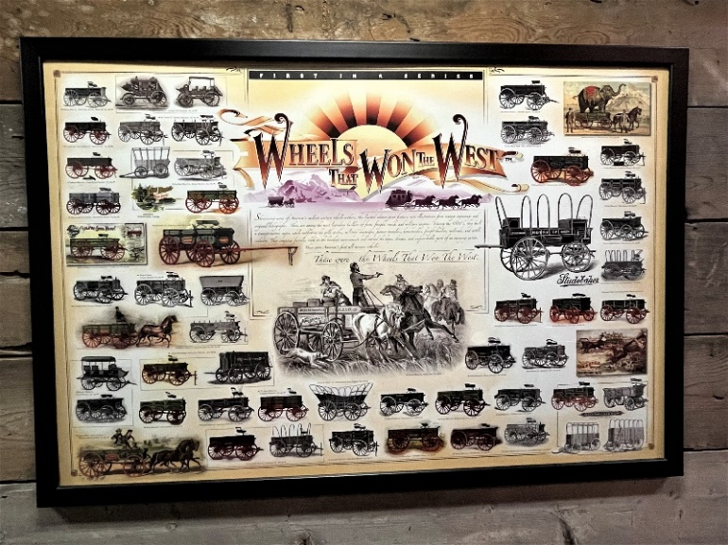

Poster shows early day wagons of all styles, to include a stagecoach, covered wagons, and other wagons, used to transport people and materials throughout the U.S. in the late 1800s and early 1900s.

RRP HOPES YOU WILL SHARE WITH US YOUR HISTORIC PHOTOS AND STORIES ABOUT ROUND ROCK:

Contact: rOUNDROCKPRESERVATION50@YAHOO.COM

INVITATION: VOLUNTEER TO BECOME A NEW RRP BOARD MEMBER. APPLICATIONS MUST BE RECEIVED PRIOR TO ANNUAL MEETING ON FEBRUARY 8.

