PO BOX 391
Round Rock TX 78680-0391

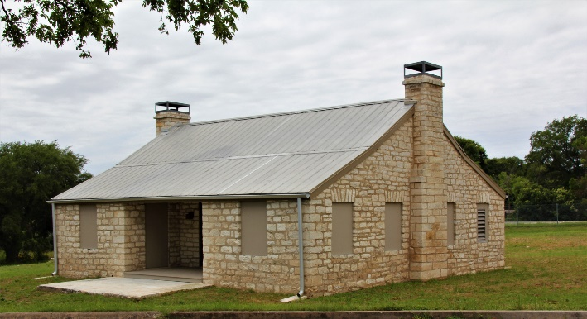

ROUND ROCK STAGECOACH INN STATUS. RR Preservation (RRP) met with City Leaders (Brooks Bennett (Asst City Manager), Rick Atkins (Director Parks & Recreation), Brad Wiseman (Director Plans & Svc) and staff members) on August 22, 2019. The group agreed to meet every 2 months to develop recommendations needed for decision making, for submission of grants and to move the RR Stagecoach Inn Restoration Project forward.

Since the relocation of the Inn took place a year ago, no new restoration actions have been accomplished and interest in the project and donations have decreased over the last year. Brooks commended RRP for raising approximately $35,000 thus far for the project. Brooks mentioned the city might consider making matching funds from Hotel Occupancy Taxes in the future to kickstart the restoration project. However, such a decision would ultimately be a City Council decision.

At this point I think the city is looking at an open room concept with possibly a floor design to show where original walls existed to the best of everyone’s knowledge. The City Historic Preservation Office proposes the first step needed is to fund a $35,000 plus Historic Preservation interior design project to develop the final interior design for the inn (insulation, roof support, A/C, electrical, etc.). However, RRP promised some contributors their donations will go for construction of wood windows and doors. In addition, funds must be reserved to pay for the engraved bricks. Therefore, the entire $35,000 is not available for funding the new design project. This is a moment when matching Hotel Occupancy matching funds are needed to move the first step in the restoration project forward.

ARCHITECTURE VOLUNTEER NEEDED. Do you know an architectural firm that will volunteer to do a 3-D rendering of how RRP envisions the interior of the Inn might look? RRP would use the rendering to brief others and to share RRP ideas with others. If you know an architect, who might volunteer, call Shirley at 512-373-3819.

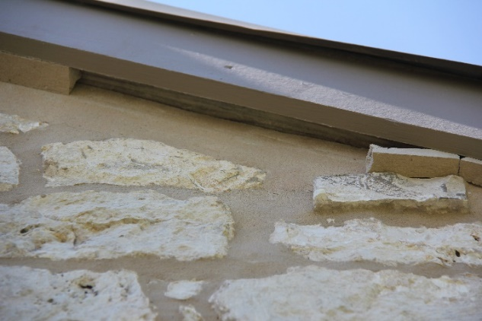

During a recent visit to the Inn, RRP noticed failing paint on the porch ceiling and failing mortar in a few places at the roof line. Since the contractor guaranteed its work for a 1-year period, the work was still under guarantee. The City looked inside the building and found there was a crack in the mortar above one of the windows. The City has contacted Phoenix I, the contractor, and they are expected to correct the issues.

PRESERVING HISTORIC ROUND ROCK PLACES
BOY SCOUT PROJECT.
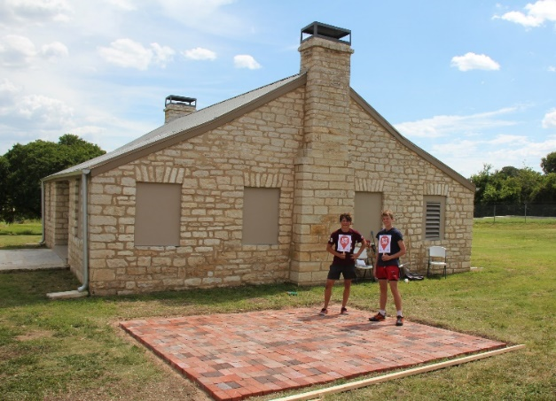
Christopher Chase, a Boy Scout who is working on his Eagle Scout Project with other Boy Scouts, installed a mock layout of the engraved brick display by the RR Stagecoach Inn. While this layout is not the final location for the brick display, the temporary display does show a mock display for the final display, which is very attractive. Bricks used in the display are not the final engraved bricks, but are bricks reused from the Commons Complex near the original site of the RR Stagecoach Inn (901 Round Rock Avenue).

REGULAR BOARD MEETINGS. You are invited to attend RRP monthly meetings. The RRP Board of Directors meets every second Tuesday of the month at the Baca Center Conference Room at 6:30 p.m. Members and guests are always welcome. Mark your calendar. Our next two meetings are scheduled for September 11 and October 9. RRP has an agenda item for citizen communication, so your voice and ideas can be heard by the Board.

ANNUAL RRP MEMBER MEETING. Members and potential members are invited to attend RRP’s Annual Membership Meeting where you can hear the status of the organization and RRP plans for 2020. The 2019 Annual Membership Meeting for RRP will be Saturday, November 2, at the RR City Library from 10:15 a.m. to 11:45 a.m.

RRP ACCEPTING APPLICATIONS FOR THE RRP BOARD OF DIRECTORS. RRP invites all members to volunteer to serve on the RRP Board of Directors. During the 2018 Annual Member Meeting, members voted to increase the number of members serving on the Board. RRP asks you to fill these openings as soon as possible. Call Shirley at 512-373-3819.

Event Calendar.

Sep 11 RRP Monthly Board Meeting (6:30 p.m. Baca)
Sep 28 Decorate Inn for Halloween (Saturday – 10 a.m.) Bring a lawn decoration to display at Inn.

Oct 09 RRP Monthly Board Meeting (6:30 p.m. Baca)
Oct 15 Qtr. Lunch & Learn (Cotton King-Sauls Family Presentation (Baca) (11:30 am-12:30)

Nov 02 Annual Member Meeting (Saturday 10:15 a.m. -12 p.m., Library Meeting Room)
Nov 09 Decorate Tree at Inn (Holidays) (Saturday – 10 a.m.) Bring ornament to decorate tree.
Nov 13 RRP Monthly Board Meeting (6:30 p.m., Baca)

Dec 11 Qtr. Lunch & Learn (State of Texas Holiday Ornaments Presentation (Williamson Museum on the Chisholm Trail, 11:30 a.m.)

2020 Qtr. Lunch & Learns - Jan 21, Apr 21, Jul 21, Oct 20 (Baca), 11:30 a.m.
May 18 HP Month History Program (May 18 (Time/Place to be determined)

DO YOU KNOW A GROUP THAT WANTS TO PARTNER WITH RRP IN CONDUCTING A FUNDRAISER IN EARLY 2020?
E-Mail: roundrockpreservation50@yahoo.com

PRESERVING HISTORIC ROUND ROCK PLACES
WWW.RRPRESERVATION.ORG

